DSA Practice Notes
A Structured Notebook for Data Structures & Algorithms
Source Repository: github.com/manishrnl/DSA-Practice-Problem

About the Author

Manish
B.Tech (2022 – 26 ) , Computer Science (AI & System Design)

Portfolio: manishrnl.in
GitHub Repository: github.com/manishrnl/DSA-Practice-Problem
This notebook compiles practice problems, patterns, and notes across core DSA modules — Bit Manipulation, Number Theory, Recursion, Backtracking, Arrays, Sorting, Searching, Hashing, and Heaps — built while preparing for SDE / Java Backend interviews.

Index

Module | Topic | LeetCode / Reference | Page
01. Bit Manipulation | 1.1 Find the Single Non-Repeating Element (others appear twice) | LC 136 - Single Number | 01 →
 | 1.2 Find Two Non-Repeating Elements (others appear twice) | LC 260 - Single Number III | 03 →
 | 1.3 Find the Single Element When Others Repeat Thrice | LC 137 - Single Number II | 05 →
 | 1.4 ( Blank pages for extra Bit Manipulation notes) | — | 07 →
02. Number Theory | 2.1 Fast / Modular Exponentiation (Calculate Power) | LC 50 - Pow(x, n) | 09 →
 | 2.2 Catalan Numbers (BST count, valid parentheses) | LC 96 - Unique BST | 11→
 | 2.3 Factorial (Iterative / Recursive) | GfG - Factorial of a Number | 13 →
 | 2.4 GCD / HCF of Two Numbers (Euclidean Algorithm) | LC 1979 - Find GCD of Array | 15 →
 | 2.5 Inclusion-Exclusion Principle | GfG - Incl-Exc Principle | 17 →
 | 2.6 Palindrome Check (Number) | LC 9 - Palindrome Number | 19 →
 | 2.7 Pigeonhole Principle Examples | GfG - Pigeonhole Principle | 21 →
 | 2.8 Prime Numbers (Sieve of Eratosthenes) | LC 204 - Count Primes | 23 →
 | 2.9 Count Trailing Zeroes in Factorial | LC 172 - Factorial Trailing 0’s | 25 →
 | 2.10 (Blank pages for extra Number Theory notes) | — | 27 →
03. Recursion | 3.1 Josephus Problem | GfG - Josephus Problem | 29 →
 | 3.2 Permutations of an Array / String | LC 46 - Permutations | 31 →
 | 3.3 Power Set (Subsets via Recursion) | LC 78 - Subsets | 33 →
 | 3.4 String Palindrome (Recursive Check) | LC 125 - Valid Palindrome | 35 →
 | 3.5 Unique Paths (Recursive Grid Traversal) | LC 62 - Unique Paths | 37 →
 | 3.6 (Blank pages for extra Recursion notes) | — | 39 →
04. Backtracking | 4.1 N-Queens Problem | LC 51 - N-Queens | 41 →
 | 4.2 Sudoku Solver | LC 37 - Sudoku Solver | 43 →
 | 4.3 (Blank pages for extra Backtracking notes) | — | 45 →
05. Array | 5.1 Majority Element (count > N/2) | LC 169 - Majority Element | 47 →
 | 5.2 Kadane's Algorithm (Maximum Subarray Sum) | LC 53 - Maximum Subarray | 49 →
 | 5.3 Trapping Rainwater Problem | LC 42 - Trapping Rain Water | 51 →
 | 5.4 Best Time to Buy and Sell Stock | LC 121 - Buy & Sell Stock | 53 →
 | 5.5 (Blank pages for extra Array notes) | — | 55 →
06. Sorting | 6.1 Bubble Sort | LC 912 - Sort an Array | 59 →
 | 6.2 Insertion Sort | LC 147 - Insertion Sort List | 61 →
 | 6.3 Selection Sort | LC 912 - Sort an Array | 67 →
 | 6.4 Merge Sort | LC 148 - Merge Sort | 63 →
 | 6.5 Quick Sort | LC 912 - Sort an Array | 65 →
 | 6.6 (Blank pages for extra Sorting notes) | — | 69 →
07. Searching | 7.1 Binary Search | LC 704 - Binary Search | 71 →
 | 7.2 Allocate Minimum Number of Pages (Binary Search on Answer) | LC 410 - Split Array Largest Sum | 73 →
 | 7.3 Linear Search | GfG - Linear Search | 75 →
 | 7.4 Search in an Infinite / Unbounded Sorted Array | LC 702 - Search in a Sorted Array of Unknown Size | 77 →
 | 7.5 Search in Sorted and Rotated Array | LC 33 - Search in Rotated Sorted Array | 79 →
 | 7.6 (Blank pages for extra Searching notes) | — | 81 →
08. Hashing | 8.1 Count Distinct Elements in Every Window of Size K | GfG - Count Distinct Elements In Every Window | 83 →
 | 8.2 Find All Distinct Elements in an Array | LC 1207 - Unique Number of Occurrences | 85 →
 | 8.3 Intersection of Two Arrays | LC 217 - Contains Duplicate | 89 →
 |  | LC 349 - Intersection of Two Arrays
 | 8.4 Subarray with Given Sum | LC 560 - Subarray Sum Equals K | 91 →
 | 8.5 Union Two Arrays + Hashing Reports | GfG - Union of Two Arrays | 93 →
 |  | LC 706 - Design HashMap
 | 8.6 (Blank pages for extra Hashing notes) | — | 97 →
09. Heap (Priority Queue) | 9.1 Min Heap Implementation | LC 215 - Kth Largest Element in an Array | 99 →
 | 9.2 Max Heap Implementatio Heap Implementation + Heap Reports | LC 1046 - Last Stone Weight | 101 →
 |  | LC 23 - Merge k Sorted Lists
 | 9.3 (Blank pages for extra Heap (Priority Queue) notes) | — | 105 →

Main Work
.
Module 01: Bit Manipulation ← Back to Index

1.1 Find the Single Non-Repeating Element (others appear twice)

Problem Statement
Find the only non-repeating element in an array where every other element repeats twice.
Problem Explanation - https://www.geeksforgeeks.org/dsa/find-element-appears-array-every-element-appears-twice/

Approach / Intuition

Code — Find the Single Non-Repeating Element (others appear twice)
import java.util.HashMap;
import java.util.Map;
public class Find1Unique {
// General Approach T.C = O(n^2) , , Space Complexity = O(1)
public int find1UniqueGeneralApproach(int[] array) {
for (int k : array) {
int value = k, count = 0;
for (int i : array)
if (value == i) count++;
if (count == 1) return value;
}
return -1;
}
// Hash Map Approach T.C = O(n) , Space Complexity = O(n)
public int find1UniqueHashMap(int[] array) {
// 1. Create the "Tally Sheet" (HashMap) , The 1st data is the KEY 2nd data is the VALUE
HashMap<Integer, Integer> results = new HashMap<>(array.length);
for (int value : array)
results.put(value, results.getOrDefault(value, 0) + 1);
// 3. Look through the finished Tally Sheet
// Map.Entry represents one "row" in your tally sheet (Key + Value)
for (Map.Entry<Integer, Integer> entry : results.entrySet()) {
// If the Value (the count) is exactly 1, we found our unique number!
if (entry.getValue() == 1) {
return entry.getKey(); // Return the Key (the original number)
}
}
// If we checked the whole map and found nothing
return -1;
}
public int find1UniqueXOR(int[] array) {
int result = 0;
for (int i = 0; i < array.length; i++)
result ^= array[i];
return result;
}
public static void main(String[] args) {
int[] array = {1, 2, 1, 3, 4, 6, 6, 7, 2, 3, 4, 5, 7};
Find1Unique obj = new Find1Unique();
// 1. General Approach
long startGeneral = System.nanoTime();
int resultGeneral = obj.find1UniqueGeneralApproach(array);
long endGeneral = System.nanoTime();
System.out.println("\n Results Via General Approach are : " + resultGeneral +
" -> Execution Time: " + (endGeneral - startGeneral) + " ns");
// 2. HashMap Approach
long startHashMap = System.nanoTime();
int resultHashMap = obj.find1UniqueHashMap(array);
long endHashMap = System.nanoTime();
System.out.println("\n Results via HashMap are : " + resultHashMap + " -> Execution" +
" Time: " + (endHashMap - startHashMap) + " ns");
// 3. XOR Approach
long startXOR = System.nanoTime();
int resultXOR = obj.find1UniqueXOR(array);
long endXOR = System.nanoTime();
System.out.println("\n Results via XOR are : " + resultXOR + " -> Execution Time: " + (endXOR - startXOR) + " ns");
}
}

Time Complexity

1.2 Find Two Non-Repeating Elements (others appear twice) ← Back to Index

Problem Statement
Find the two non-repeating elements in an array where every other element repeats twice.
https://www.geeksforgeeks.org/dsa/find-two-non-repeating-elements-in-an-array-of-repeating-elements/

Code — Find Two Non-Repeating Elements (others appear twice)
import java.util.*;
public class Find2Unique {
public int[] find2UniqueGeneralApproach(int[] array) {
int length = array.length;
List<Integer> lists = new ArrayList<>();
for (int value : array) {
int count = 0;
for (int i : array) {
if (value == i) count++;
}
if (count == 1) lists.add(value);
}
int[] result = new int[lists.size()];
for (int i = 0; i < lists.size(); i++)
result[i] = lists.get(i);
return result;
}
public int[] find2UniqueHashMap(int[] array) {
HashMap<Integer, Integer> map = new HashMap<>();
for (int value : array) map.put(value, map.getOrDefault(value, 0) + 1);
List<Integer> uniqueList = new ArrayList<>();
for (Map.Entry<Integer, Integer> entry : map.entrySet()) {
if (entry.getValue() == 1) uniqueList.add(entry.getKey());
}
int[] result = new int[uniqueList.size()];
int index = 0;
for (int num : uniqueList) result[index++] = num;
return result;
}
public int[] find2UniqueXOR(int[] array) {
// Step 1: XOR all elements.
// Pairs cancel out. resultXOR will be (Unique1 ^ Unique2)
int combinedXOR = 0;
for (int num : array) combinedXOR ^= num;
// Step 2: Isolate the rightmost "set bit" (the rightmost 1).
// This bit represents a position where Unique1 and Unique2 are DIFFERENT.
// Formula: x & -x gives the lowest bit that is 1.
int rightmostSetBit = combinedXOR & -combinedXOR;
int[] result = new int[2];
// Step 3: Divide numbers into two groups based on that specific bit.
for (int num : array) {
// Group A: Numbers that have 0 at this bit position
if ((num & rightmostSetBit) == 0) result[0] ^= num;
// Group B: Numbers that have a 1 at this bit position
else result[1] ^= num;
}
return result;
}
public static void main(String[] args) {
int[] array = {1, 2, 3, 2, 1, 4};
Find2Unique obj = new Find2Unique();
long startGeneral = System.nanoTime();
int[] resultGeneral = obj.find2UniqueGeneralApproach(array);
long endGeneral = System.nanoTime();
System.out.println("Result via General Approach is : " + Arrays.toString(resultGeneral) + " -> Execution Time : " + (endGeneral - startGeneral) + " ns");
long startHashMap = System.nanoTime();
int[] resultHashMap = obj.find2UniqueHashMap(array);
long endHashMap = System.nanoTime();
System.out.println("Result via Hash Map Approach is : " + Arrays.toString(resultHashMap) + " -> Execution Time : " + (endHashMap - startHashMap) + " ns");
long startXOR = System.nanoTime();
int[] resultXOR = obj.find2UniqueXOR(array);
long endXOR = System.nanoTime();
System.out.println("Result via XOR Approach is : " + Arrays.toString(resultXOR) + " -> Execution Time : " + (endXOR - startXOR) + " ns");
}
}

1.3 Find the Single Element When Others Repeat Thrice ← Back to Index

Problem Statement
Find the only non-repeating element in an array where every other element repeats thrice.
https://www.geeksforgeeks.org/dsa/find-unique-element-element-occurs-k-times-except-one/

Approach / Intuition

Code — Find the Single Element When Others Repeat Thrice
import java.util.*;
public class Find3Unique {
public int find3UniqueHashMap(int[] array, int k) {
HashMap<Integer, Integer> freqMap = new HashMap<>();
// 1. Fill the frequency map
for (int value : array)
freqMap.put(value, freqMap.getOrDefault(value, 0) + 1);
for (Map.Entry<Integer, Integer> entry : freqMap.entrySet()) {
if (entry.getValue() != k) return entry.getKey();
}
return -1;
}
public int find3UniqueXOR(int[] array, int k) {
int INT_SIZE = 32;
int[] bitCounts = new int[INT_SIZE];
// 2. Count the occurrences of '1' bits at each of the 32 positions
for (int i = 0; i < INT_SIZE; i++) {
for (int num : array) {
// If the i-th bit of 'num' is set (1), increment the counter for that position
if ((num & (1 << i)) != 0) {
bitCounts[i]++;
}
}
}
// Now consider all bits whose count is
// not multiple of k to form the required
// number.
int res = 0;
for (int i = 0; i < INT_SIZE; i++)
res += (bitCounts[i] % k) * (1 << i);
// Before returning the res we need
// to check the occurrence of that
// unique element and divide it
res = res / (array.length % k);
return res;
}
public static void main(String[] args) {
int[] array = {1, 2, 3, 2, 1, 3, 1, 2, 3, 8, 8};
Find3Unique obj = new Find3Unique();
long startHashMap = System.nanoTime();
int resultHashMap = obj.find3UniqueHashMap(array, 3);
long endHashMap = System.nanoTime();
System.out.println("Result via Hash Map Approach is : " + (resultHashMap) + " -> Execution Time : " + (endHashMap - startHashMap) + " ns");
long startXOR = System.nanoTime();
int resultXOR = obj.find3UniqueXOR(array, 3);
long endXOR = System.nanoTime();
System.out.println("Result via XOR Approach is : " + resultXOR + " -> Execution Time : " + (endXOR - startXOR) + " ns");
}
}

Notes if Any :

1.4 Bit Manipulation — Extra Notes ← Back to Index

Module 02: Number Theory ← Back to Index

2.1 Fast / Modular Exponentiation (Calculate Power)

Code — Fast / Modular Exponentiation (Calculate Power)
import java.math.BigInteger;
public class CalculatePower {
public long calculatePower(long base, long power) {
long result = 1;
result = (long) Math.pow(base, power);
System.out.printf("Power of %d ^ %d via Math.pow() is : ", base, power);
return result;
}
/**
* Optimized Power function using Binary Exponentiation.
* Time Complexity: O(log power)
* Space Complexity: O(1)
*/
public long calculatePowerBitsOptimized(long base, long power) {
System.out.printf("Power of %d ^ %d via Bits Calculation is : ", base, power);
// Edge case: Any number to the power of 0 is 1
if (power == 0) return 1;
// Edge case: 0 to any positive power is 0
if (base == 0) return 0;
long result = 1;
// Using a long for the base internally to prevent
// immediate overflow during the squaring step
long currentProduct = base;
while (power > 0) {
// If the least significant bit is 1, multiply result by currentProduct
// (power & 1) is a faster way to check if power is odd
if ((power & 1) != 0) {
result *= currentProduct;
}
// Square the base for the next bit position
currentProduct *= currentProduct;
// Logical right shift to move to the next bit
power = power >> 1;
}
return result;
}
public long calculateFastPower(long base, long power, long n) {
/* PROPERTY USED:
(a + b) % n = (a % n + b % n) % n
(a - b) % n = (a % n - b % n) % n
(a * b) % n = (a % n * b % n) % n
(a / b) % n = (a % n / b % n) % n
*/
System.out.printf("Power of %d ^ %d with 10 ^ %d { %d } via Bits Calculation is : ",
base, power, String.valueOf(n).length(), n);
// Edge case: if n is 1, the result is always 0
if (n == 1) return 0;
long result = 1;
// Initial mod to handle cases where base >= n
base %= n;
while (power > 0) {
// If the current bit of 'power' is 1 (power is odd)
// Multiply the result with the current base
if ((power & 1) != 0) {
result = (result * base) % n;
}
// Square the base for the next bit position
// Example: 3^1 -> 3^2 -> 3^4 -> 3^8
base = (base * base) % n;
// Right shift 'power' to process the next bit
// Equivalent to power = power / 2
power = power >> 1;
}
return result;
}
public BigInteger calculateTruePower(String base, long power) {
BigInteger b = new BigInteger(base);
BigInteger result = b.pow((int) power);
System.out.printf("Power of %s ^ %d Via True Power is : ", base, power);
return result;
}
public static void main(String[] args) {
long base = 12333L, power = 266L;
long n = 1000000000L;
CalculatePower calculatePower = new CalculatePower();
long startTime = System.currentTimeMillis();
long resultMath = calculatePower.calculatePower(base, power);
long endTime = System.currentTimeMillis();
System.out.println(resultMath + " -> Time taken to execute is : " + (endTime - startTime) + " ns");
long startBits = System.nanoTime();
long resultBits = calculatePower.calculatePowerBitsOptimized(base, power);
long endBits = System.nanoTime();
System.out.println(resultBits + " -> Time taken to execute is : " + (endBits - startBits) + " ns");
long startFastPower = System.nanoTime();
long resultFastPower = calculatePower.calculateFastPower(base, power, n);
long endFastPower = System.nanoTime();
System.out.println(resultFastPower + " -> Time taken to execute is : " + (endFastPower - startFastPower) + " ns");
long startTruePower = System.nanoTime();
BigInteger resultTruePower = calculatePower.calculateTruePower(String.valueOf(base),
power);
long endTruePower = System.nanoTime();
System.out.println(resultTruePower + " -> Time taken to execute is : " + (endTruePower - startTruePower) + " ns");
}
}

Notes if Any :

2.2 Catalan Numbers (BST count, valid parentheses) ← Back to Index

Problem Statement

What are Catalan Numbers?

Catalan numbers are a sequence of natural numbers that occur in various counting problems, particularly those involving recursive structures.
The $n$-th Catalan number, denoted as $C_{n}$, counts things like:
- Valid Parentheses: The number of ways to arrange $n$ pairs of () so they are correctly nested.
- Binary Search Trees: The number of unique BSTs that can be formed with $n$ nodes.
- Mountain Ranges: Ways to draw $n$ upstrokes and $n$ downstrokes that never stay below the horizon.
The sequence starts: 1, 1, 2, 5, 14, 42, 132...

Approach / Intuition

The Mathematical Formula
While there is a recursive formula, the most efficient way to calculate $C_{n}$ for a specific $n$ is using the Binomial Coefficient:
$$C_{n}=\frac{1}{n+1}\left({2n \atop n}\right)$$Optimized Code (Linear Time)
This calculates $C_{n}$ in $O(n)$ time and $O(1)$ space.
We use the iterative property: $C_{n+1}=\frac{2(2n+1)}{n+2}C_{n}$.

Code — Catalan Numbers (BST count, valid parentheses)
import java.math.BigInteger;
public class CatalanNumbers {
// Time Complexity: O(n) , Space Complexity: O(1)
public long findCatalanViaLong(int n) {
long res = 1;
// Using the formula: C(n) = C(n-1) * { (4n - 2) / (n + 1) }
for (int i = 1; i <= n; i++) {
// Multiply by (4i - 2)
res = res * (4L * i - 2);
// Divide by (i + 1)
res = res / (i + 1);
}
return res;
}
public BigInteger findCatalanViaBigInteger(int n) {
BigInteger result = BigInteger.ONE;
for (int i = 1; i <= n; i++) {
result = result.multiply(BigInteger.valueOf(4L * i - 2));
result = result.divide(BigInteger.valueOf(i + 1));
}
return result;
}
public static void main(String[] args) {
CatalanNumbers cn = new CatalanNumbers();
int ng = 14 , nb=4344;
long start = System.nanoTime();
long result = cn.findCatalanViaLong(ng);
long end = System.nanoTime();
System.out.println("The " + ng + "-th Catalan Number is: " + result);
System.out.println("Length: " + String.valueOf(result).length() + " digits");
System.out.println("Time: " + (end - start) + " ns");
long start1 = System.nanoTime();
BigInteger result1 = cn.findCatalanViaBigInteger(nb);
long end1 = System.nanoTime();
System.out.println("The " + nb + "-th Catalan Number is: " + result1);
System.out.println("Length: " + result1.toString().length() + " digits");
System.out.println("Time: " + (end1 - start1) + " ns");
}
}

2.3 Factorial (Iterative / Recursive) ← Back to Index

Code — Factorial (Iterative / Recursive)
import java.math.BigInteger;
public class Factorial {
public BigInteger findFactorialViaBigInteger(int n) {
if (n <= 1) return BigInteger.ONE;
return BigInteger.valueOf(n).multiply(findFactorialViaBigInteger(n - 1));
}
public long findFactorialGenerally(int n) {
long factorial = 1;
if (n <= 1) return 1;
return (n * findFactorialGenerally(n - 1));
}
public static void main(String[] args) {
Factorial factorial = new Factorial();
long startTime = System.nanoTime();
BigInteger result = factorial.findFactorialViaBigInteger(12);
long endTime = System.nanoTime();
int size = result.toString().length();
System.out.printf(result + "\n Size of result is %d Digits long and -> Execution " +
"time is %d ns ", size, (endTime - startTime));
long startTime1 = System.nanoTime();
long result1 = factorial.findFactorialGenerally(12);
long endTime1 = System.nanoTime();
long size1 = String.valueOf(result1).length();
System.out.printf("\n Results are " + result1 + "\n Size of result is %d Digits long" +
" and -> Execution time is %d ns ", size1, (endTime1 - startTime1));
}
}

Notes if Any :

2.4 GCD / HCF of Two Numbers (Euclidean Algorithm) ← Back to Index

Code — GCD / HCF of Two Numbers (Euclidean Algorithm)
public class GCD {
public long greatestCommonDivision(int num1, int num2) {
if (num2 == 0) return num1;
if (num1 == 0) return num2;
return greatestCommonDivision(num1, num1 % num2);
}
public static void main(String[] args) {
GCD gcd = new GCD();
System.out.print("GCD of numbers are : ");
long startTime = System.nanoTime();
long result = gcd.greatestCommonDivision(0, 47);
long endTime = System.nanoTime();
System.out.println(result + " -> Execution time for function :" + (endTime - startTime) + " ns");
}
}

Notes if Any :

2.5 Inclusion-Exclusion Principle ← Back to Index

Problem Statement

Inclusion-Exclusion is a counting technique used to find the size of the union of multiple sets. It helps to avoid the "double-counting" trap when sets overlap.

The "Party Guest" Rule
Imagine you are hosting a party and checking your guest list:
Step 1: You count everyone who likes Pizza.
Step 2: You count everyone who likes Burgers.
Step 3: You realize the people who like BOTH were counted twice! (Once in the Pizza group and once in the Burger group).
The Fix: You subtract the "Both" group once to get the true number of unique guests.
That is Inclusion-Exclusion.

Approach / Intuition
/**
* @param index Which prime we are currently looking at
* @param currentDivisor The product of the primes we've chosen so far
* @param limit The number we are checking up to (e.g., 100)
* @param primes Our list of divisors (e.g., {2, 3, 5})
*/
Instead of using confusing bitmasks, we can use a simple recursive "Decision Tree." For every number (like 2, 3, or 5), we have two choices: Use it or Skip it.

Code — Inclusion-Exclusion Principle
public class InclusionExclusion {
public long countTotalDivisorsEfficient(int index, long currentDivisor, long limit,
int[] primes) {
// Base Case: If we've looked at all primes, stop.
if (index == primes.length) return 0;
// 1. Calculate for the current prime
long combinedDivisor = currentDivisor * primes[index];
// This is how many numbers are divisible by our "chosen" group
long countWithThisPrime = limit / combinedDivisor;
// 2. The Magic Logic:
// We add the count of the current group,
// then subtract the count of the NEXT group to fix the overlaps.
return countWithThisPrime
+ countTotalDivisorsEfficient(index + 1, currentDivisor, limit, primes) // Option A: Skip this prime
- countTotalDivisorsEfficient(index + 1, combinedDivisor, limit, primes); // Option B: Include this prime
}
public static void count_Total_Divisors_LongMethod(int n) {
int count = 1;
// Count the number of integers divisible by 2
for (int i = 2; i < n; i += 2) count++;
// Count the number of integers divisible by 3
for (int i = 3; i < n; i += 3) count++;
// Count the number of integers divisible by 5
for (int i = 5; i < n; i += 5) count++;
// Count the number of integers divisible by both 2 and 3
for (int i = 6; i < n; i += 6) count--;
// Count the number of integers divisible by both 2 and 5
for (int i = 10; i < n; i += 10) count--;
// Count the number of integers divisible by both 3 and 5
for (int i = 15; i < n; i += 15) count--;
// Count the number of integers divisible by 2, 3, and 5
for (int i = 30; i < n; i += 30) count++;
// Print the final count
System.out.println("Long Method Result: " + count);
}
public static void main(String[] args) {
InclusionExclusion obj = new InclusionExclusion();
int[] primes = {2, 3, 5};
long limit = 1584565654L;
// --- Timing Efficient Method ---
long startEff = System.nanoTime();
long resultEff = obj.countTotalDivisorsEfficient(0, 1, limit, primes);
long endEff = System.nanoTime();
System.out.println("Efficient Method Result: " + resultEff);
System.out.println("Efficient Method Time: " + (endEff - startEff) + " ns");
System.out.println("------------------------------------");
// --- Timing Long Method ---
long startLong = System.nanoTime();
count_Total_Divisors_LongMethod((int) limit);
long endLong = System.nanoTime();
System.out.println("Long Method Time: " + (endLong - startLong) + " ns");
// Final comparison
double ratio = (double) (endLong - startLong) / (endEff - startEff);
System.out.printf("\nThe Efficient method was %.2f times faster! \n", ratio);
}
}

2.6 Palindrome Check (Number) ← Back to Index

Code — Palindrome Check (Number)
public class Palindrome {
public void palindrome(int n) {
int result = 0;
for (int i = n; i > 0; i /= 10) {
int mod = i % 10;
result = result * 10 + mod;
}
if (n == result)
System.out.printf("Number %d is a palindrome", n);
else System.out.printf("Number %d is not a palindrome", n);
}
public static void main(String[] args) {
Palindrome test = new Palindrome();
long startTime = System.nanoTime();
test.palindrome(404);
long endTime = System.nanoTime();
System.out.print(" -> Time taken for execute function is : " + (endTime - startTime) +
" ns");
}
}

Notes if Any :

2.7 Pigeonhole Principle Examples ← Back to Index

Problem Statement

The Pigeonhole Principle (PHP) is a simple yet powerful concept in combinatorics. It states that:
If you have $n$ items (pigeonholes) and $m$ items (pigeons) to put into them, and $m>n$, then at least one pigeonhole must contain more than one pigeon.
Imagine you have 3 pigeonholes but 4 pigeons. No matter how hard you try to spread them out, one hole will end up with at least 2 pigeons.

Common Real-World Examples
- Birthdays: In a group of 367 people, at least two must share a birthday (since there are only 366 possible birthdays, including Feb 29).
- Hair: There are more people in New York City than there are hairs on a human head. Therefore, at least two people in NYC have the exact same number of hairs.
- Arrays: If you have an array of size $N$ containing numbers from $1$ to $N-1$, at least one number must be a duplicate.

Coding Application: Finding a Duplicate
One of the most common ways we use PHP in coding is to find a duplicate in a constrained list.

Problem: You have an array of $n+1$ integers where each integer is between $1$ and $n$ inclusive. Find the duplicate.

The "Fast" Way (Bit Manipulation / Frequency Array)
While we could use nested loops ($O(n^{2})$), the Pigeonhole Principle tells us a duplicate must exist, so we can use a frequency array (the "holes") to catch it in $O(n)$ time.

Code — Pigeonhole Principle Examples
import java.util.ArrayList;
import java.util.List;
public class PigeonholeExample {
public static int findDuplicate(int[] number) {
boolean[] holes = new boolean[number.length];
for (int num : number) {
// If the 'hole' is already occupied, we found our duplicate!
if (holes[num]) {
return num;
}
// Otherwise, put the 'pigeon' in the hole
holes[num] = true;
}
return -1; // Should not happen based on PHP
}
public static void totalDuplicate(int[] number) {
List<Integer> totalDuplicates = new ArrayList<>();
boolean[] holes = new boolean[number.length];
for (int value : number) {
if (holes[value])
totalDuplicates.add(value);
holes[value] = true;
}
System.out.print("Total Duplicates value found are : ");
for (int value : totalDuplicates)
System.out.print(value + " ");
}
public static void main(String[] args) {
int[] pigeons = {1, 2, 3, 4, 2,3,4}; // 5 items, values 1-4
System.out.println("Very 1st duplicate pigeon among all duplicates is: " + findDuplicate(pigeons));
totalDuplicate(pigeons);
}
}

OUTPUT:
Very 1st duplicate pigeon among all duplicates is: 2
Total Duplicates value found are : 2 3 4

2.8 Prime Numbers (Sieve of Eratosthenes) ← Back to Index

Code — Prime Numbers (Sieve of Eratosthenes)
import java.util.Arrays;
public class PrimeNumbers {
public boolean[] sieveOfEratoSthenes(int n) {
boolean[] isPrime = new boolean[n + 1];
Arrays.fill(isPrime, true);
isPrime[0] = isPrime[1] = false;//Discarding index 0,1 as we are interested in no.
// from 2 to n . we keep position and index same for not getting confused ,
// therefore initialised isPrime =new boolean[n+1]
for (int i = 2; i * i <= n; i++) { // Iterate till squareRoot(n) times only as after
// that all factors is checked
for (int j = 2 * i; j <= n; j += i) { // Marking multiples of j to false so we
// get true for only prime numbers once loops gets over
isPrime[j] = false;
}
}
return isPrime;
}
public static void main(String[] args) {
PrimeNumbers p = new PrimeNumbers();
long startTime = System.nanoTime();
boolean[] result = p.sieveOfEratoSthenes(100);
long endTime = System.nanoTime();
System.out.print("Prime Numbers are : ");
for (int i = 0; i < result.length; i++)
if (result[i]) System.out.print(i + " ");
System.out.print(" -> Time taken to execute function is : " + (endTime - startTime) +
" ns");
}
}

OUTPUT:
Prime Numbers are : 2 3 5 7 11 13 17 19 23 29 31 37 41 43 47 53 59 61 67 71 73 79 83 89 97 -> Time taken to execute function is : 39800 ns

2.9 Count Trailing Zeroes in Factorial ← Back to Index

Problem Statement
Find number of trailing 0’s in n!

Approach / Intuition
0 Occurs due to 2 * 5 = 10 , so count total no of 5 . that will give trailing zeroes.
REMEMBER : at 25 we get TWO 5's similarly at 125 , 625 , and so on , therefore we
are checking loop from i=5 to <=n at interval of i*5

Code — Count Trailing Zeroes in Factorial
public class Trailing_Zeroes {
public int trailingZeroes(int n) {
int result = 0;
System.out.print("Trailing Zeroes in " + n + " ! is : ");
for (int i = 5; i <= n; i *= 5) {
result += n / i;
}
return result;
}
public static void main(String[] args) {
Trailing_Zeroes test = new Trailing_Zeroes();
long startTime = System.nanoTime();
int result = test.trailingZeroes(87);
long endTime = System.nanoTime();
System.out.print(result + " -> Time Taken to compute is : " + (endTime - startTime) + " ns");
}
}

OUTPUT:
Trailing Zeroes in 87 ! is : 20 -> Time Taken to compute is : 1886200 ns

2.10 Number Theory — Extra Notes ← Back to Index

Module 03: Recursion

3.1 Josephus Problem ← Back to Index

Problem Statement
This uses a Recursive Relation. If we know the survivor position for (n-1) people, we can find the position for n people by
shifting the index by 'k' and taking the modulo 'n'.
@param n Total number of people
@param k The step rate (every k-th person is eliminated)
@return The 0-indexed position of the survivor

Code — Josephus Problem
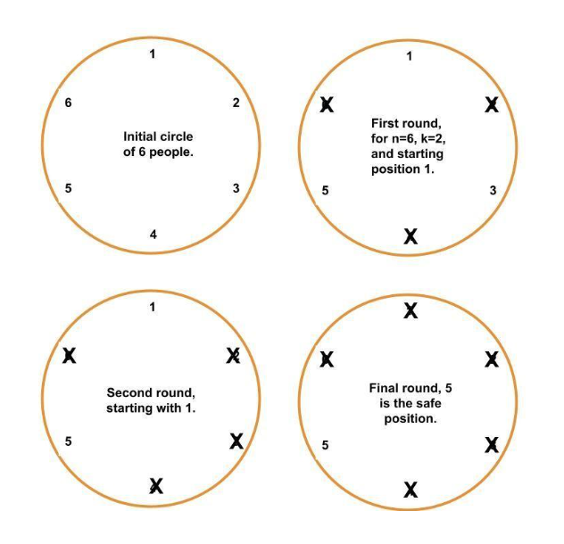
public static long josephProblem(int n, int k) {
// Base Case: If there is only 1 person, they are the survivor (at index 0)
if (n == 1) {
return 0;
}
/* * Recursive Step:
* 1. Solve the problem for n-1 people.
* 2. Add k to shift the starting point.
* 3. Use % n to wrap around the circle.
*/
return (josephProblem(n - 1, k) + k) % n;
}
public static void main(String[] args) {
int n = 6;
int k = 2;
long survivorPosition = josephProblem(n, k);
System.out.println("The survivor in a circle of " + n +" people with a step of " + k +"starting from position 1 is at index: " + survivorPosition);
}

OUTPUT:
The survivor in a circle of 6 people with a step of 2 starting from position 1 is at index: 5

Notes if Any :

3.2 Permutations of an Array / String ← Back to Index

Problem Statement
/**
* Problem: Print All Permutations
* Logic: Use Backtracking. We swap the current character with every character appearing after it to create new arrangements.
* After the recursive call, we swap back (backtrack) to restore the original string for the next iteration.
* @param str The string to permute
* @param startIndex The starting index of the window
* @param endIndex The ending index of the window
*/

Code — Permutations of an Array / String
public class Permutations {
public static void printAllPermutations(String str, int startIndex, int endIndex) {
// Base Case: If the window has narrowed to a single character
if (startIndex == endIndex) {
System.out.print(str + " ");
return;
}
for (int i = startIndex; i <= endIndex; i++) {
// Step 1: Swap character at 'left' with character at 'i'
str = swap(str, startIndex, i);
// Step 2: Recurse for the rest of the string
printAllPermutations(str, startIndex + 1, endIndex);
// Step 3: Backtrack (Swap back to original)
str = swap(str, startIndex, i);
}
}
private static String swap(String str, int i, int j) {
char[] charArray = str.toCharArray();
char temp = charArray[i];
charArray[i] = charArray[j];
charArray[j] = temp;
return String.valueOf(charArray);
}
public static void main(String[] args) {
String s = "abcd";
System.out.println("Permutations of " + s + ": \n");
printAllPermutations(s, 0, s.length() - 1);
}
}

3.3 Power Set (Subsets via Recursion) ← Back to Index

Problem Statement
* Problem: Print Power Set
* Logic: For every character in the string, we have two choices:
* 1. Include the character in the current subset.
* 2. Exclude the character from the current subset.
* This creates a binary recursion tree.
* @param str The original string
* @param index The current character we are considering
* @param current The subset built so far

Code — Power Set (Subsets via Recursion)
public class PowerSet {
public static void printPowerSet(String str, int index, String current) {
// Base Case: If we have considered all characters
if (index == str.length()) {
System.out.println("\"" + current + "\"");
return;
}
// Choice 1: Include the current character
printPowerSet(str, index + 1, current + str.charAt(index));
// Choice 2: Exclude the current character
printPowerSet(str, index + 1, current);
}
public static void main(String[] args) {
String s = "abc";
System.out.println("Power Set of " + s + ":");
printPowerSet(s, 0, "");
}
}

Notes if Any :

3.4 String Palindrome (Recursive Check) ← Back to Index

Code — String Palindrome (Recursive Check)
public class StringPalindrome {
// This matches your requested signature
public static boolean stringPalindrome(String str) {
// Base case: null or empty strings are technically palindromes
if (str == null || str.isEmpty()) return true;
// Call the helper method with the initial start and end positions
return stringPalindrome(str, 0, str.length() - 1);
}
// This is the recursive helper that uses your specific logic
private static boolean stringPalindrome(String str, int startIndex, int lastIndex) {
// Base case: If the pointers meet or cross, every character matched
if (startIndex >= lastIndex) return true;
char startChar = str.charAt(startIndex);
char endChar = str.charAt(lastIndex);
// If characters at current pointers don't match, it's not a palindrome
if (startChar != endChar) return false;
// Recursive call: move pointers inward
return stringPalindrome(str, startIndex + 1, lastIndex - 1);
}
public static void main(String[] args) {
String str = "Mams";
boolean result = stringPalindrome(str.toLowerCase());
String response = result ? "It is a Palindrome " : "It is not a Palindrome ";
System.out.println(response);
}
}

Notes if Any :

3.5 Unique Paths (Recursive Grid Traversal) ← Back to Index

Problem Statement
* Logic: This is a recursive implementation of the "Pascal's Identity".
* Every cell in the grid (except the first row and first column) can be reached from exactly two directions:
* 1. From the Top (rows - 1)
* 2. From the Left (columns - 1)
* * Base Case: If you are in the first row (rows == 1) or first column (columns == 1),
* there is only 1 straight path to reach any cell in that line.
* * Complexity: T.C: O(2^(n+m)) , S.C : O(n+m) - Due to the recursion stack.

Code — Unique Paths (Recursive Grid Traversal)
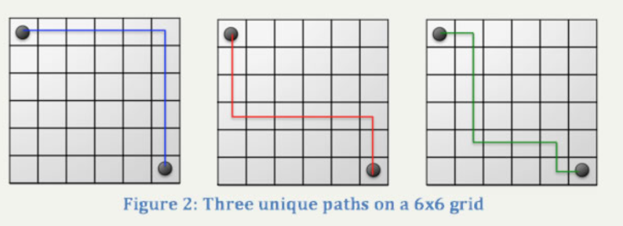
public class UniquePaths {
public static long countUniquePaths(int rows, int columns) {
// If we are at the edge (first row or first column), only 1 way exists (straight line)
if (rows == 1 || columns == 1) return 1;
// Total ways = ways from the top cell + ways from the left cell
return countUniquePaths(rows - 1, columns) + countUniquePaths(rows, columns - 1);
}
// Optimized above code to O(n*m) version
public static long countPathsDP(int rows, int columns) {
long[][] dp = new long[rows][columns];
for (int i = 0; i < rows; i++) {
for (int j = 0; j < columns; j++) {
if (i == 0 || j == 0) dp[i][j] = 1; // Base case
else dp[i][j] = dp[i - 1][j] + dp[i][j - 1]; // Sum of top and left
}
}
return dp[rows - 1][columns - 1];
}
public static void main(String[] args) {
int rows = 12, columns = 15;
long startTime = System.nanoTime(); long result = countUniquePaths(rows, columns);
long endTime = System.nanoTime();
System.out.println("Results via Recursion Problem: " + result + " in " + (endTime - startTime) + " ns");
long startTime1 = System.nanoTime(); long result2 = countPathsDP(rows, columns);
long endTime1 = System.nanoTime();
System.out.println("Results via DP Approach : " + result2 + " in " +(endTime1 - startTime1) + " ns");
}
}

3.6 Recursion — Extra Notes ← Back to Index

Module 04: Backtracking

4.1 N-Queens Problem ← Back to Index

Problem Statement
Given “n” Queen to be placed in a n x n chess board in such a way that no 2 queen can attack each other.

Approach / Intuition
Place Queens at any place starting from [0,0] now check if next queen can be placed in a next row such that it cant cancel each other . if they attacks , backtrack one step and recheck for next place.
/**
* We only need to check 3 directions (Up, Up-Left, Up-Right)
* because we haven't placed any queens below the current row yet.
* Also bottom will always be empty , we are inserting from top .
* so checking bottom doesn't make sense
*/

Code — N-Queens Problem
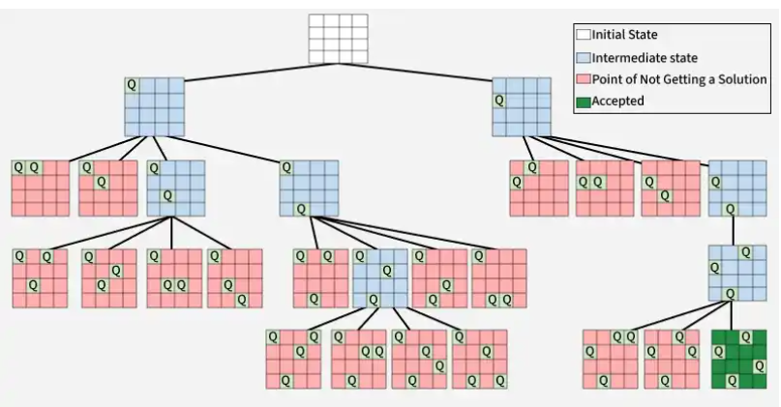
public class N_Queen {
static int N = 25;
public static boolean solve(int[][] board, int row) {
// BASE CASE: If we reached the end, we found a solution!
if (row == N) return true;
for (int col = 0; col < N; col++) {
if (isSafe(board, row, col)) {
board[row][col] = 1; // Place Queen
// Move to the next row
if (solve(board, row + 1)) return true;
// BACKTRACK: "Undo" the placement if it didn't work out
board[row][col] = 0;
}
}
return false;
}
private static boolean isSafe(int[][] board, int row, int col) {
// We only need to check 3 directions (Up, Up-Left, Up-Right) because we haven't placed any queens below the current row yet. Also bottom will always be empty , we are inserting from top . so checking bottom doesn't make sense
for (int i = 1; i <= row; i++) {
// 1. Check Straight Up till (row,0)
if (board[row - i][col] == 1) return false;
// 2. Check Up-Left Diagonal till (row-i,col-i)
if (col - i >= 0 && board[row - i][col - i] == 1) return false;
// 3. Check Up-Right Diagonal till (row-i,col+i)
if (col + i < N && board[row - i][col + i] == 1) return false;
}
return true;
}
public static void main(String[] args) {
long startTime = System.nanoTime();
int[][] board = new int[N][N];
if (solve(board, 0)) {
long endTime = System.nanoTime();
System.out.printf(" Time taken to complete backTracking : %d ns\n\n", (endTime - startTime));
printBoard(board);
}
}
private static void printBoard(int[][] board) {
for (int[] row : board) {
for (int cell : row) {
System.out.print(cell == 1 ? "Q " : ". ");
}
System.out.println();
}
}
}

Notes if Any :

4.2 Sudoku Solver ← Back to Index

Problem Statement

This Sudoku solver is a perfect example of Recursive Backtracking . It essentially uses a "Brute Force" approach but with a brain—it drops a path the moment it violates a rule.

Approach / Intuition
Before the algorithm can try a number, it needs to know where to put it.Once it finds the very first digits = 0 , it breaks , goes inside another loop to check at $safeSearch(..)$ , then if placing digits is successfully done, it again comes back here to find next 0 .
This continues untill all are filled and no 0's are left
Once a cell is picked, the code enters a loop from 1 to 9

3. The Validation Phase (isSafe)
This is the "Rules of the Game" section. It checks three distinct constraints:
if(board[row][i]==num ||board[i][col]==num)return false;
It scans the entire horizontal row and vertical column. If num exists there, it's an immediate "No."

B. The 3x3 Grid Check
This is usually the most confusing part for developers. How do we know which 3x3 box we are in?

The "Validator" Logic (Explained Meaningfully)
The isSafe(..) function acts as a pre-condition validator. It treats the num as a candidate, checking its compatibility against the existing constraints of the board (Row, Column, and 3x3 Box) before any state change occurs.
Because the candidate is not yet written into the matrix, the function effectively performs a collision check in a read-only state. If the candidate clears all three 'gatekeepers' without a conflict, the calling function is granted permission to 'commit' that value to the board. If a conflict is found, the candidate is rejected immediately, saving the algorithm from exploring an invalid path.

Code — Sudoku Solver
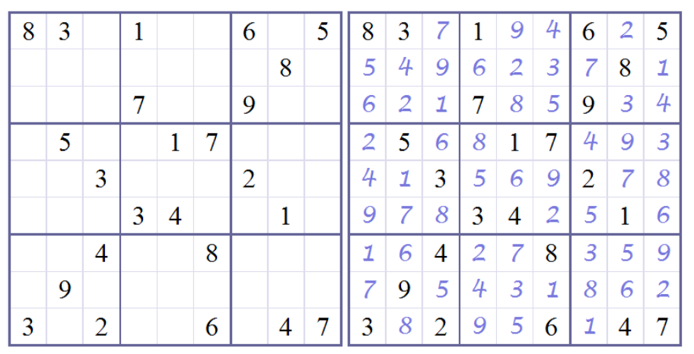
public class SudokuSolver {
public static boolean solveSudoku(int[][] board) {
int n = board.length;
int row = -1;
int col = -1;
boolean emptyLeft = false;
// 1. Find the first empty cell (0)
for (int i = 0; i < n; i++) {
for (int j = 0; j < n; j++) {
if (board[i][j] == 0) {
row = i;
col = j;
emptyLeft = true;
break;
}
}
if (emptyLeft) break;
}
// Base Case: No empty cells left, Sudoku is solved!
if (!emptyLeft) return true;
// 2. Try numbers 1 to 9
for (int num = 1; num <= 9; num++) {
if (isSafe(board, row, col, num)) {
board[row][col] = num;
// Move to next step
if (solveSudoku(board)) return true;
// BACKTRACK: Undo the choice
board[row][col] = 0;
}
}
return false;
}
private static boolean isSafe(int[][] board, int row, int col, int num) {
// Check Row and Column
int rowLength = board.length;
int colLength = board[0].length;
for (int i = 0; i < rowLength; i++) {
if (board[row][i] == num || board[i][col] == num) return false;
}
// Check 3x3 Sub-grid This math finds the "top-left" corner of the 3x3 box
int rowStart = row - (row % 3);
int colStart = col - (col % 3);
for (int i = rowStart; i < rowStart + 3; i++) {
for (int j = colStart; j < colStart + 3; j++) {
if (board[i][j] == num) return false;
}
}
return true;
}
public static void main(String[] args) {
int[][] board = {
{8, 3, 0, 1, 0, 0, 6, 0, 5},
{0, 0, 0, 0, 0, 0, 0, 8, 0},
{0, 0, 0, 7, 0, 0, 9, 0, 0},
{0, 5, 0, 0, 1, 7, 0, 0, 0},
{0, 0, 3, 0, 0, 0, 2, 0, 0},
{0, 0, 0, 3, 4, 0, 0, 1, 0},
{0, 0, 4, 0, 0, 8, 0, 0, 0},
{0, 9, 0, 0, 0, 0, 0, 0, 0},
{3, 0, 2, 0, 0, 6, 0, 4, 7}
};
if (solveSudoku(board)) printBoard(board);
}
private static void printBoard(int[][] board) {
for (int[] row : board) {
for (int cell : row) System.out.print(cell + " ");
System.out.println();
}
}
}

Notes if Any :

4.3 Backtracking — Extra Notes ← Back to Index

Module 05: Array

5.1 Majority Element (count > N/2) ← Back to Index

Problem Statement
Print largest number that occurs maximum times & is greater than N/2 in an array .
Example. In array of length n=34 {18, 18, 12, 12, 12, 12, 12, 12, 12, 12, 12, 12, 12, 18, 18, 45, 18, 18, 18, 18, 18, 18, 18, 18, 18, 18, 18, 18, 18, 18, 18, 18, 18, 1};
N/2 = 17 ,Largest Number that occurs maxm times & is greater that 17 is 18

Code — Majority Element (count > N/2)
import java.util.HashMap;
public class Count_Number_Greater_Than_2 {
// Print number greater than N/2 in an array T.C = O(N)
public static int getMaxOccurrence(int[] number) {
HashMap<Integer, Integer> map = new HashMap<>(number.length);
for (int value : number) map.put(value, map.getOrDefault(value, 0) + 1);
// 2. Efficiency Trick: Iterate over EntrySet instead of KeySet.
// This gives us the Key and Value at the same time . No need to call map.get() again.
for (HashMap.Entry<Integer, Integer> entry : map.entrySet()) {
if (entry.getValue() > (number.length >> 2) && entry.getKey() > (number.length / 2))
return entry.getKey();
}
return -1;
}
public static void main(String[] args) {
int[] array = {18, 18, 20, 20, 20, 20, 20, 20, 12, 12, 12, 12, 12, 12, 12, 12, 12, 12, 12, 18, 18, 45, 18, 18, 18, 18, 18, 18, 18, 18, 18, 18, 18, 18, 18, 18, 18, 18, 18, 1};
System.out.println(array.length);
long startTime = System.nanoTime();
int result = getMaxOccurrence(array);
long endTime = System.nanoTime();
String response = result > 0 ? “Number Greater than N / 2 is : “ + result : “No such number found which satisfy condition number >(N / 2 ) “;
System.out.println(response + “ -> Time taken by algorithm is “ + (endTime – startTime) + “ ns”);
}
}

5.2 Kadane's Algorithm (Maximum Subarray Sum) ← Back to Index

Problem Statement
Finds the Maximum Subarray Sum using Kadane’s Algorithm.

Approach / Intuition
THE LOGIC: This algorithm is an optimized "Greedy" approach that solves the problem in a single pass (O(N)). It operates on a simple principle:"A subarray should only continue as long as its sum remains positive. If the 'currentSum' becomes negative, it means the preceding elements are a 'burden' that would reduce the sum of any future subarray. Therefore, we 'reset' the currentSum to 0 and start a fresh subarray from the next element.

Code — Kadane's Algorithm (Maximum Subarray Sum)
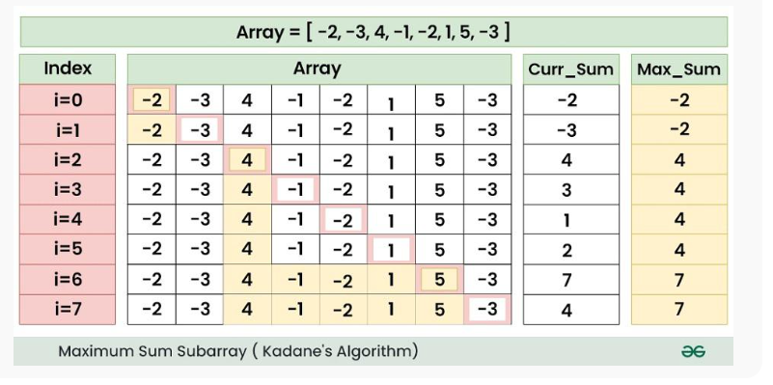
public class KadaneAlgorithm {
public static int max__Pair_Sum(int[] array) {
// 'maxSum' acts as the global record holder. 'currentSum' tracks the current contiguous sequence.
int maxSum = Integer.MIN_VALUE, currentSum = 0;
for (int i = 0; i < array.length; i++) {
currentSum += array[i]; // Step 1: Accumulate the current element into our local window.
// Step 2: If the local window is the best we've seen so far, update the global record.
if (currentSum > maxSum) maxSum = currentSum;
// Step 3: THE RESET. If the window becomes a net-negative, it cannot contribute
// positively to future elements. We discard it and reset the search.
if (currentSum < 0) currentSum = 0;
}
return maxSum;
}
public static int Approach2(int[] array) {
int length = array.length;
int maxSum = Integer.MIN_VALUE;
for (int i = 0; i < length; i++) {
int currentSum = 0;
for (int j = i; j < length; j++) {
currentSum += array[j];
if (currentSum > maxSum)
maxSum = currentSum;
if (currentSum < 0)
currentSum = 0;
}
}
return maxSum;
}
public static void main(String[] args) {
int[] array = {-10, -3000, -4, 500, 4, 5, 6, 7, 8, -9000, 4, 900, -200, 800, 200, 30, -50, -70};
long startTime = System.nanoTime();
int result = max__Pair_Sum(array);
long endTime = System.nanoTime();
int result1 = Approach2(array);
long endTime1 = System.nanoTime();
System.out.println("Result via O(N) method is : " + result + " -> Time taken by algorithm is " + (endTime - startTime) + " ns");
System.out.println("Result via O(N^2) method is : " + result1 + " -> Time taken by algorithm is " + (endTime1 - endTime) + " ns");
}
}

OUTPUT:
Result via O(N) method is : 1734 -> Time taken by algorithm is 2900 ns
Result via O(N^2) method is : 1734 -> Time taken by algorithm is 8100 ns

Notes if Any :

5.3 Trapping Rainwater Problem ← Back to Index

Problem Statement
Given an array representing the height of a bars . Calculate how much amount of it can trap after raining.

Approach / Intuition
ORIGINAL APPROACH: Pre-calculating Left and Right Max
* Logic: Create two arrays to store the maximum height seen so far from the left and right.
* The Logic: For any bar at index i, the water level is:
* water[i] = min(maxLeft , maxRight) - height[i]
* * Time Complexity: O(N) - Three linear passes. Space Complexity: O(N) - Two extra arrays of size N.

Code — Trapping Rainwater Problem
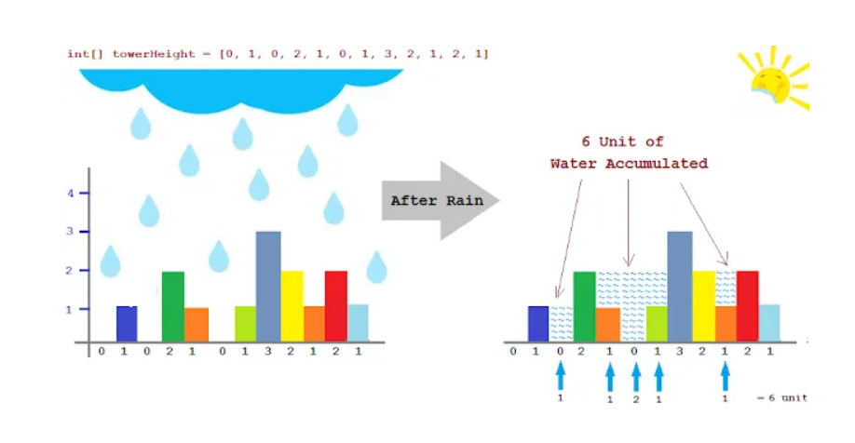
import static java.lang.System.nanoTime;
import static java.lang.System.out;
public class Rainwater_Trapping_Problem {
public static int rainwater(int[] array) {
int length = array.length;
if (length == 0) return 0;
int leftMax = array[0], rightMax = array[length - 1];
int[] left = new int[length], right = new int[length];
// Fill Left Max array
left[0] = array[0];
for (int i = 1; i < length; i++) {
leftMax = Math.max(leftMax, array[i]);
left[i] = leftMax;
}
// Fill Right Max array
right[length - 1] = array[length - 1];
for (int i = length - 2; i >= 0; i--) {
rightMax = Math.max(rightMax, array[i]);
right[i] = rightMax;
}
int sum = 0;
for (int i = 0; i < length; i++) {
// Water trapped = min(highest left, highest right) - current height
sum += Math.min(left[i], right[i]) - array[i];
}
return sum;
}
/** OPTIMIZED APPROACH: Two Pointers
* Logic: Instead of arrays, use two pointers (left and right). Move the pointer
* pointing to the smaller height, as that's the "bottleneck" for water trapping.
* * Time Complexity: O(N) - Single pass. * Space Complexity: O(1) - No extra arrays used.
public static int rainwaterOptimized(int[] array) {
int n = array.length;
if (n <= 2) return 0; // Need at least 3 bars to trap water
int left = 0, right = n - 1;
int leftMax = 0, rightMax = 0;
int totalWater = 0;
while (left < right) {
if (array[left] < array[right]) {
// If current bar is taller than leftMax, update it
if (array[left] >= leftMax) {
leftMax = array[left];
} else {
// Otherwise, we can trap water
totalWater += leftMax - array[left];
}
left++;
} else {
if (array[right] >= rightMax) {
rightMax = array[right];
} else {
totalWater += rightMax - array[right];
}
right--;
}
}
return totalWater;
}
public static void main(String[] args) {
int[] array = {3, 1, 2, 4, 0, 1, 3, 13, 1, 2};
// Test Original
long start1 = nanoTime();
int res1 = rainwater(array);
long end1 = nanoTime();
// Test Optimized
long start2 = nanoTime();
int res2 = rainwaterOptimized(array);
long end2 = nanoTime();
out.println("Original Result T.C O(N) , S.C (O(N) : " + res1 + " | Time: " + (end1 - start1) + " ns");
out.println("Optimized Result T.C O(N) , S.C (O(1) : " + res2 + " | Time: " + (end2 - start2) + " ns");
}
}

OUTPUT:
Original Result T.C O(N) , S.C (O(N) : 12 | Time: 48000 ns
Optimized Result T.C O(N) , S.C (O(1) : 12 | Time: 2500 ns

5.4 Best Time to Buy and Sell Stock ← Back to Index

Problem Statement
Find Maximum profit possible by buying a stock and then selling it .

Approach / Intuition
APPROACH 3: One-Pass (Optimal)
Logic: Iterate through the prices while keeping track of the lowest price seen so far. For every new price, calculate the potential profit if we sold today using that minimum price.
Time Complexity: O(N) - We only scan the array once. Space Complexity: O(1) - We only store two integer variables.

Code — Best Time to Buy and Sell Stock

public class StockAndBuy {
// APPROACH 1: Brute Force Logic: Check every possible combination of buy and sell days.
public static int maxProfitBruteForce(int[] prices) {
int maxProfit = 0;
for (int i = 0; i < prices.length; i++) {
// 'j' starts from 'i + 1' because you must buy before you can sell
for (int j = i + 1; j < prices.length; j++) {
int profit = prices[j] - prices[i];
if (profit > maxProfit) maxProfit = profit;
}
}
return maxProfit;
}
// APPROACH 2: Auxiliary Space (Suffix Max)
Logic: Pre-calculate the maximum price that occurs in the future for any given day.By storing the "best possible sell price" for each day in a separate array, we can find the profit in a single second pass.
public static int maxProfitWithSpace(int[] prices) {
int n = prices.length;
if (n < 2) return 0;
// Create an array where maxFuturePrices[i] is the highest price from day 'i' to the end
int[] maxFuturePrices = new int[n];
maxFuturePrices[n - 1] = prices[n - 1];
// Fill the array from right to left
for (int i = n - 2; i >= 0; i--)
maxFuturePrices[i] = Math.max(prices[i], maxFuturePrices[i + 1]);
int maxProfit = 0;
// The profit for day 'i' is the (max future price) - (price on day 'i')
for (int i = 0; i < n; i++) {
maxProfit = Math.max(maxProfit, maxFuturePrices[i] - prices[i]);
}
return maxProfit;
}
/** APPROACH 3: One-Pass (Optimal)
* Logic: Iterate through the prices while keeping track of the lowest price
* seen so far. For every new price, calculate the potential profit if we
* sold today using that minimum price.
* * Time Complexity: O(N) - We only scan the array once.
* Space Complexity: O(1) - We only store two integer variables.
*/
public static int maxProfitOptimized(int[] prices) {
if (prices == null || prices.length == 0) return 0;
int minPrice = Integer.MAX_VALUE; // Track the cheapest day to buy
int maxProfit = 0; // Track the best profit found
for (int price : prices) {
if (price < minPrice) {
// Found a new historical low; update buy price
minPrice = price;
} else if (price - minPrice > maxProfit) {
// If selling today yields a better profit than before, update it
maxProfit = price - minPrice;
}
}
return maxProfit;
}
public static void main(String[] args) {
int[] array = {1, 3, 2, 4, 6, 8, 9, 11, 9, 4, 126};
long startTime = nanoTime();
int result = maxProfitBruteForce(array);
long endTime = nanoTime();
long startTime2 = nanoTime();
int result2 = maxProfitOptimized(array);
long endTime2 = nanoTime();
long startTime3 = nanoTime();
int result3 = maxProfitWithSpace(array);
long endTime3 = nanoTime();
out.println("--- Results ---");
out.println("Brute Force T.C : O(N^2) & S.C : O(1) is : " + result + " (" + (endTime - startTime) + " ns)");
out.println("Optimized T.C : O(N) & S.C : O(N) is : " + result2 + "(" + (endTime2 - startTime2) + " ns)");
out.println("Suffix Max T.C : O(N) & S.C : O(1) is : " + result3 + " (" + (endTime3 - startTime3) + " ns)");
}
}

OUTPUT:
Brute Force T.C : O(N^2) & S.C : O(1) is : 125 (4600 ns)
Optimized T.C : O(N) & S.C : O(N) is : 125(1900 ns)
Suffix Max T.C : O(N) & S.C : O(1) is : 125 (39000 ns)

5.5 Array — Extra Notes ← Back to Index

Module 06: Sorting

6.1 Bubble Sort ← Back to Index

Problem Statement

1. Bubble Sort: "Neighbor-to-Neighbor"
Idea: Adjacent comparison. Largest element “bubbles” to the end.

Approach / Intuition
BUBBLE SORT LOGIC
1. The Comparison: Start at the beginning of the array. Compare the current element (A) with its immediate neighbor (B).
2. The Swap: If A > B, swap them. This ensures the larger value "bubbles" toward the right.
3.Iteration: Move to the next pair (B & C) and repeat comparison until the end of the unsorted portion of the array is reached.
4. The Pass: After one full pass, largest element of the unsorted section is guaranteed to be in its final sorted position at end.
5. Repeat: Repeat process for remaining unsorted elements. With each subsequent pass, range of comparison decreases by one.
6. Optimization (Optional): If a full pass occurs without any swaps, the array is already sorted, algorithm can terminate early.
T.C Best O(N) , worst case O(N^2) S.C O(1)

Code — Bubble Sort
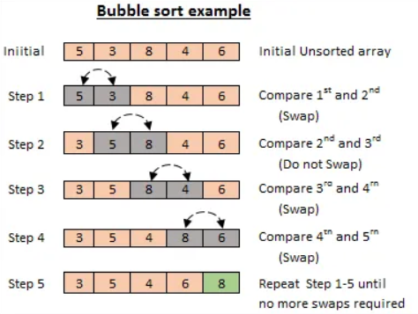
import java.util.Arrays;
import static java.lang.System.nanoTime;
import static java.lang.System.out;
public class S1_BubbleSort {
public static int[] bubbleSort(int[] array) {
int length = array.length;
for (int i = 0; i < length - 1; i++) {
boolean swapped = false;
for (int j = 0; j < length - i - 1; j++) {
if (array[j] > array[j + 1]) {
/**
* ARCHITECTURAL NOTE ON FUNCTION CALLS:
* Theoretically, a function call adds overhead (stack pushing , context switching , adding new memory ,
* RAM etc. ). However, the modern JVM's JIT (Just-In-Time) Compiler performs "Method Inlining" injecting
* the swap logic directly into the loop (into the called function) to eliminate call overhead
* at runtime. Calling a different function inside a function is just for humans
* readibility . It doesn't affect program overhead via context switching etc.
*/
swapNumbers(array, j, j + 1);
swapped = true;
}
}
// EARLY EXIT OPTIMIZATION: If no elements were swapped during
// a full pass, meaning the array is already sorted.
if (!swapped) break;
}
return array;
}
public static void swapNumbers(int[] array, int i, int j) {
int temp = array[i];
array[i] = array[j];
array[j] = temp;
}
public static void main(String[] args) {
int size = 5000;
int[] array = new int[size];
// Fill the array with random numbers.
for (int i = 0; i < size; i++) {
int randomNumber = (int) (Math.random() * size);
array[i] = randomNumber;
}
out.println("Starting Bubble Sort for " + size + " elements...");
long startFunction = nanoTime();
int[] result = bubbleSort(array);
long endFunction = nanoTime();
out.println("Result: " + Arrays.toString(result));
out.println("-> Time taken: " + (endFunction - startFunction) + " ns");
out.println("-> Time in seconds: " + (double) (endFunction - startFunction) / 1_000_000_000 + " s");
}
}

Notes if Any :

6.2 Insertion Sort ← Back to Index

Problem Statement

2. Insertion Sort: "Shift and Slide"
Idea: Insert element into correct position in sorted section.

Approach / Intuition
LOGIC for Insertion Sort
Think of the array as being split into two parts: a sorted part on the left and an unsorted part on the right.
1. Initially, the "sorted" part is just the first element array[0], because a single number is always sorted by itself.
2. We pick the first element from the unsorted part (the "Key").
3. We look at the sorted part to its left and shift every number that is larger than our "Key" one position to the right.
4. This creates an empty slot where the "Key" finally fits.
5. The "Sorted Wall" moves one step to the right, and we repeat
T.C: Best O(N) , Average O(N^2), and Worst O(N^2) S.C: O(1) - Sorting is performed in-place without auxiliary memory.

Code — Insertion Sort
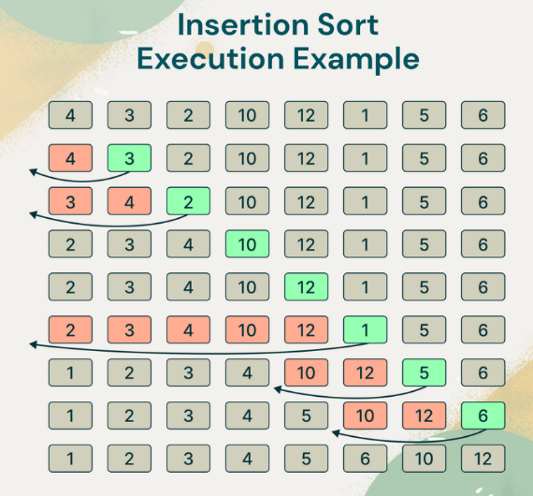
public class S2_InsertionSort {
public static int[] insertionSort(int[] array) {
int length = array.length;
for (int i = 1; i < length; i++) { // Start from the second element (index 1)
int key = array[i]; // 1. Pick the element to be inserted
int j = i - 1; // 2. Start comparing with the element immediately to the left
while (j >= 0 && array[j] > key) { // 3. The "Shifting" Phase
array[j + 1] = array[j]; // Move the larger element to the right
j = j - 1; // Move the pointer further left
}
// 4. The "Insertion" Phase
array[j + 1] = key; // Drop the key into its correct hole
}
return array;
}
public static void main(String[] args) {
int[] array = {1, 4, 3, 2, -1, 4, 77, 89, 54, 23, 78, 13};
long startFunction = nanoTime(); int[] result = insertionSort(array);
long endFunction = nanoTime();
out.println("Result for Insertion Sort : " + Arrays.toString(result));
out.println("-> Time taken by algorithm is: " + (endFunction - startFunction) + " ns");
}
}

6.3 Selection Sort ← Back to Index

Problem Statement

3. Selection Sort: "Search and Swap"
Idea: Find minimum → swap once → grow sorted section.

Approach / Intuition
Selection Sort is an in-place comparison-based algorithm that conceptually divides the array into two parts:
1. A sorted sublist (built from left to right) , 2. An unsorted sublist (the remainder of the array).
In each iteration, the algorithm scans the unsorted sublist to find the minimum element and swaps it with the first element of that unsorted section. This "selects" the correct element for the current position and expands the sorted boundary by one.
* * Time Complexity: - Best, Average, and Worst Case: O(N²)
* * Space Complexity: O(1

Code — Selection Sort
import java.util.Arrays;
import static java.lang.System.out;
public class S3_SelectionSort {
public static int[] selectionSort(int[] array) {
int n = array.length;
// The outer loop moves the boundary between the sorted and unsorted parts. Everything to the left of 'i' is already sorted.
for (int i = 0; i < n - 1; i++) {
// STEP 1: Assume the first element of the unsorted part is the smallest. We store its INDEX, not its value, so we can swap
int minIndex = i;
// STEP 2: The inner loop scans the remaining unsorted elements (from i + 1 to the end) to find the actual minimum value.
for (int j = i + 1; j < n; j++) {
if (array[j] < array[minIndex]) {
// We found a new "champion" smallest value
minIndex = j;
}
}
int temp = array[minIndex];
array[minIndex] = array[i];
array[i] = temp;
// LOGIC CHECK: After this swap, the element at index 'i' is officially sorted. The loop
then moves to 'i + 1' to find the next smallest.
}
return array;
}
public static void main(String[] args) {
int[] data = {29, 10, 14, 37, 13, 12, 3, 34, 456, 5, 4, 6, 56, 7, 6, 8, 78, 456, 79, 456, 89, 890, 456, 909, 0, 9, 0, 9, 0, 8, 9, 788, 7, 456, 67, 8, 6, 7, 5, 7, 56, 6, 546, 56, 5, 6, 56, 5, 6, 5, 6, 5, 6, 56, 456, 56, 5, 6, 56, 5, 6, 5, 6, 5, 6, 5, 6, 5, 66, 7, 67, 8, 78, 6, 3, 4, 2, 3, 13, 23, 45656767, 867, 89, 78890, 879, 89};
out.println("\nOriginal: " + Arrays.toString(data));
long start = System.nanoTime();
selectionSort(data);
long end = System.nanoTime();
out.println("Sorted: " + Arrays.toString(data) + " \n->Time taken to Execute is " + (end - start) + " ns");
}
}
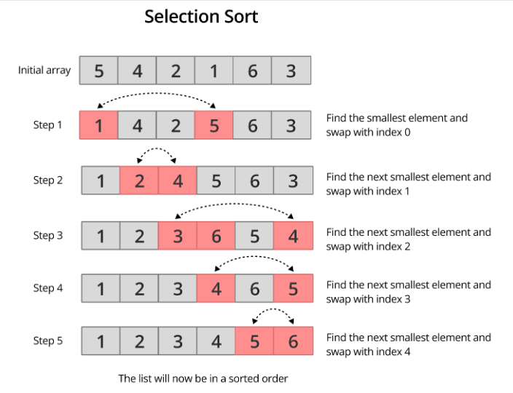

Notes if Any :

6.4 Merge Sort ← Back to Index

Problem Statement

B. Divide and Conquer Sorts ($O(Nlog⁡N)$)
These algorithms use recursion to break problems into smaller parts.

4. Merge Sort: "Split and Zip"
Idea: Split → recursively → merge sorted arrays.

Approach / Intuition
* ================= MERGE SORT (MENTAL MODEL) =================
* Think in 2 phases:
* 1) GO DOWN (Divide phase) * - Keep splitting array into halves Stop when size becomes 1 (already sorted)
* 2) COME UP (Merge phase) * - Now start merging small sorted arrays - Build bigger sorted arrays step by step
* IMPORTANT RULE: * merge() is called ONLY when both left and right are already sorted
* =============================================================
* Time Complexity: O(N log N) * Space Complexity: O(N)

Code — Merge Sort
public class S4_MergeSort {
public static int[] mergeSort(int[] array) {
if (array.length <= 1) return array; // BASE CASE: If array has 1 element →
// already sorted → return
int mid = array.length / 2; // 🔹 STEP 1, DIVIDE : Split array into two halves
int[] leftArray = Arrays.copyOfRange(array, 0, mid), rightArray = Arrays.copyOfRange(array, mid, array.length);
/* 🔥 RECURSION FLOW (VERY IMPORTANT) * Execution does NOT go like normal top-to-bottom. It goes like:
* 1. Go LEFT completely (until base case)
* 2. Then go RIGHT completely
* 3. THEN merge
* Think: "I will NOT merge until both sides are fully sorted"
// 🔹 STEP 2: SORT LEFT HALF (go deep first)
out.println("Splitting Left Part ..........." + Arrays.toString(leftArray));
mergeSort(leftArray);
out.println("All Left Array is being split up : " + Arrays.toString(leftArray));
// 🔹 STEP 2: SORT RIGHT HALF
out.println("Splitting Right Part ..........." + Arrays.toString(rightArray));
mergeSort(rightArray);
out.println("All Right Array is being split up : " + Arrays.toString(rightArray));
// 🔹 STEP 3: MERGE (happens while returning back)
// At this point:
// leftArray is sorted ✔
// rightArray is sorted ✔
out.println("Now merging the splitted Array");
merge(array, leftArray, rightArray);
out.println("\n\n");
return array;
}
/** ================= MERGE FUNCTION =================
* Input:
* left[] → already sorted
* right[] → already sorted
* Output:
* result[] → combined sorted array
* Idea:
* Compare the smallest elements from both arrays Pick the smaller one and move forward
private static void merge(int[] result, int[] leftArray, int[] rightArray) {
int leftIndex = 0; // pointer for left array
int rightIndex = 0; // pointer for right array
int k = 0; // pointer for result array
// 🔹 Compare elements from both arrays
while (leftIndex < leftArray.length && rightIndex < rightArray.length) {
if (leftArray[leftIndex] <= rightArray[rightIndex])
result[k++] = leftArray[leftIndex++]; // take from left
else
result[k++] = rightArray[rightIndex++]; // take from right
}
// 🔹 Copy remaining elements (if any)
while (leftIndex < leftArray.length) // If left still has elements
result[k++] = leftArray[leftIndex++];
while (rightIndex < rightArray.length) // If right still has elements
result[k++] = rightArray[rightIndex++];
out.println("====================== Merge Result ======================== " + Arrays.toString(result));
}
public static void main(String[] args) {
int[] data = {1, 29, 10, 14, 37, 13, 12, 3, 34, 456, 5, 4, 6, 56, 7, 6, 8, 78};
out.println("\nOriginal: " + Arrays.toString(data));
long start = System.nanoTime();
mergeSort(data);
long end = System.nanoTime();
out.println("Sorted: " + Arrays.toString(data));
out.println("Time taken: " + (end - start) + " ns");
}
}
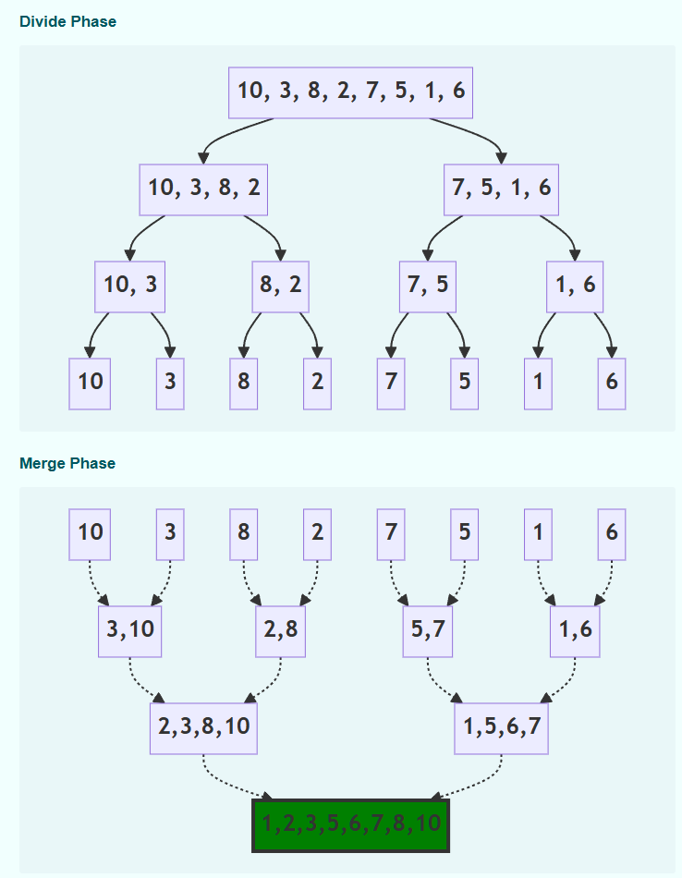
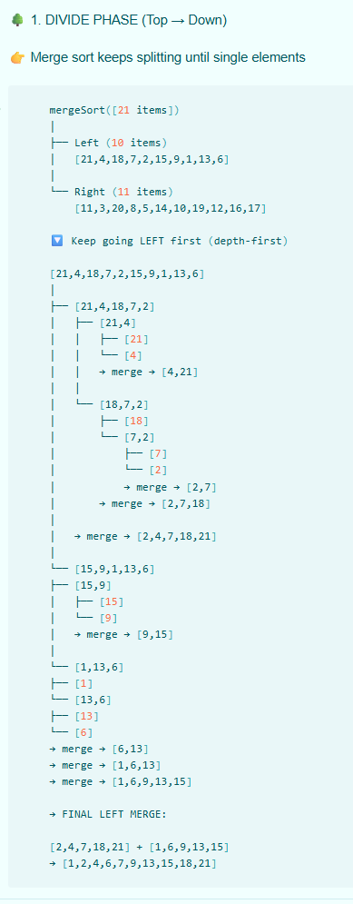
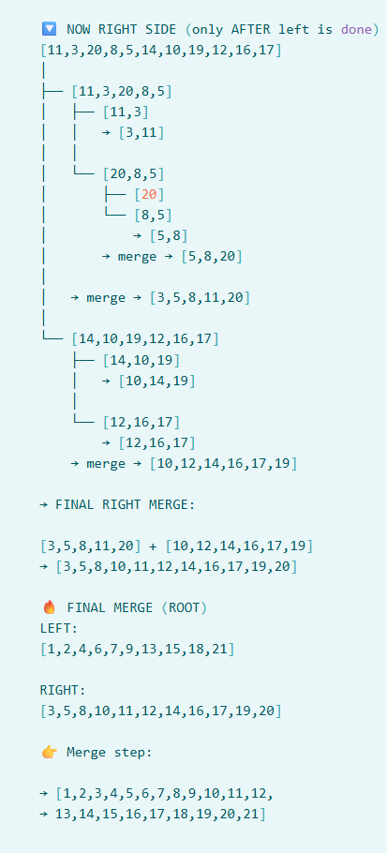


6.5 Quick Sort ← Back to Index

Problem Statement

5. Quick Sort: "Pivot Partition"
Idea: Choose pivot → partition → recurse.

Approach / Intuition
Quick Sort is a Divide & Conquer algorithm that picks an element as a 'pivot' & partitions the given array around picked pivot.
Logic: * 1. Pivot Selection: Pick an element (commonly the last element).
* 2. Partitioning: Rearrange array so that all elements smaller than pivot are on left, & all elements larger are on right.
* 3. Recursion: Recursively apply the same logic to the left and right sub-arrays.
* * * Time Complexity: * - Best & Average Case: O(N log N) * Worst Case: O(N²) - * * * Space Complexity: * - O(log N)

Code — Quick Sort
import java.util.Arrays;
import static java.lang.System.out;
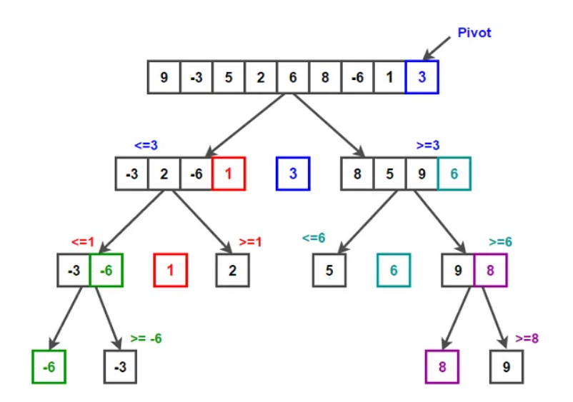
public class S5_QuickSort {
public static int[] quickSort(int[] array) {
if (array == null || array.length == 0)
return array;
sort(array, 0, array.length - 1);
return array;
}
private static void sort(int[] array, int low, int high) {
if (low < high) {
int pivot = partition(array, low, high);
sort(array, low, pivot - 1); // Left side
sort(array, pivot + 1, high); // Right side
}
}
private static int partition(int[] array, int low, int high) {
int pivot = array[high]; // We choose the last element as the pivot
int i = (low - 1);
for (int j = low; j < high; j++) {
if (array[j] < pivot) {
i++;
int temp = array[i];
array[i] = array[j];
array[j] = temp;
}
}
// Final Swap: Place the pivot in its correct sorted position by swapping it with the element at i + 1.
int temp = array[i + 1];
array[i + 1] = array[high];
array[high] = temp;
return i + 1; // Return the position of the pivot
}
public static void main(String[] args) {
int[] data = {29, 10, 14, 37, 13, 12, 3, 34, 456, 5, 4, 6, 56, 7, 6, 8, 78, 456, 79, 456, 89, 890, 456
, 909, 0, 9, 0, 9, 0, 8, 9, 788, 7, 456, 67, 8, 6, 7, 5, 7, 56, 6, 546, 56, 5, 6, 56, 5, 6, 5, 6, 5, 6, 56, 456, 56, 5, 6, 56, 5 , 6, 5, 6, 5, 6, 5, 6, 5, 66, 7, 67, 8, 78, 6, 3, 4, 2, 3, 13, 23, 45656767, 867, 89, 78890, 879, 89};
out.println("\nOriginal: " + Arrays.toString(data));
long start = System.nanoTime();
quickSort(data);
long end = System.nanoTime();
out.println("Sorted: " + Arrays.toString(data) + " \n->Time taken to Execute is " + (end - start) + " ns");
}
}

Notes if Any :

6.7 Sorting — Extra Notes ← Back to Index

Module 07: Searching

7.1 Binary Search ← Back to Index

Problem Statement
In this , we are to search elements “key” in a sorted array

Approach / Intuition
Divide the array into 2 parts on the basis of array length.
If middle elements is greater than the key , then elements must be present in left part. So discard the right part completely and repeats above process , i.e., find middle elements then compare with key and so on…

Code — Binary Search
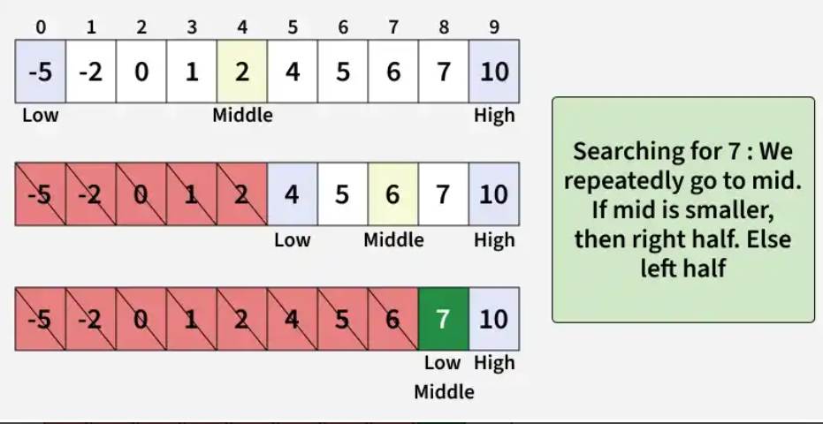
import java.io.*;
import java.util.Arrays;
public class BinarySearch {
public static boolean binarySearch(int[] array, int key) {
int low = 0, high = array.length - 1;
int operationPerformed = 0;
while (low <= high) {
int mid = (low + high) / 2;
if (array[mid] == key) {
System.out.printf("Elements Found at index %d & Total Operations performed " +
"to search elements %d is : %d OPERATIONS\n", mid, key, operationPerformed);
return true;
}
if (key < array[mid]) {
high = mid - 1;
operationPerformed++;
}
if (key > array[mid]) {
low = mid + 1;
operationPerformed++;
}
}
System.out.printf("Elements Not found & Total Operations performed to search " +
"elements %d is %d OPERATIONS \n", key, operationPerformed);
return false;
}
public static boolean recursionBinarySearch(int[] array, int key, int low, int high,
int totalOperations) {
// Base case , Elements not found , returning false
if (low > high) {
return false;
}
int mid = (high + low) / 2;
if (array[mid] == key) {
System.out.printf("Elements Found at index %d via Recursion & Total operations " +
"taken to search element %d is : %d OPERATIONS \n", mid, key,
totalOperations);
return true;
}
if (array[mid] > key)
return recursionBinarySearch(array, key, low, (mid - 1), totalOperations + 1);
if (array[mid] < key)
return recursionBinarySearch(array, key, (mid + 1), high, totalOperations + 1);
System.out.println("Elements Not Found ");
return false;
}
public static void main(String[] args) throws IOException {
int[] array = {0, 2, 4, 5, 5, 8, 9, 10, 10, 11, 11, 12, 13, 14, 15, 15, 17, 18, 18, 19, 19, 20, 22, 22, 24, 24, 24, 24, 26, 32, 37, 38, 38, 39, 39, 40, 4999};
BufferedReader bufferedReader = new BufferedReader(new InputStreamReader(System.in));
int key;
do {
System.out.println(Arrays.toString(array));
System.out.print("Enter elements to Search from above list ( -1 to QUIT ) : -> ");
String input = bufferedReader.readLine();
key = Integer.parseInt(input);
long startFunction = System.nanoTime();
binarySearch(array, key);
long endFunction = System.nanoTime();
recursionBinarySearch(array, key, 0, array.length - 1, 0);
long endRecursion = System.nanoTime();
System.out.printf("Time taken to execute function via Normal Binary Search : %d ns " +
"\n", (endFunction - startFunction));
System.out.printf("Time taken to execute function via Recursion : %d ns \n", (endRecursion - endFunction));
} while (key != -1);
}
}

7.2 Allocate Minimum No. of Pages ( Google Interview ) ← Back to Index

Problem Statement
* GOOGLE INTERVIEW QUESTION
Given an array of pages where array[i] represents number of pages in i-th book, and 'k' students, allocate books such that:
* 1. Each student gets at least one book.
* 2. Each student reads a contiguous sequence of books.
* 3. The maximum number of pages assigned to any single student is MINIMIZED.

Approach / Intuition
Core Logic
- Search Space: The answer must lie between the maximum pages in a single book (low) and the sum of all pages (high).
- Binary Search: Check the middle value (mid). If it is possible to allocate books such that no student reads more than mid pages, look for a smaller maximum (high = mid - 1). Otherwise, increase the limit (low = mid + 1).
- Feasibility Check: Iterate through the books and greedily assign them to students without exceeding mid pages per student. [1, 2, 3, 4, 5]

Code — Allocate Minimum Number of Pages (Binary Search on Answer)
public class BookAllocation {
public int minPages(int[] array, int totalStudents) {
// Base case: If books are fewer than students, allocation isn't possible
// under the "at least one book per student" rule.
if (array.length < totalStudents) return -1;
int min = maxOf(array); // A student must be able to hold at least the largest book
int max = sumOf(array); // Max limit is one student reading everything
int res = -1;
while (min <= max) {
int mid = min + (max - min) / 2; // Prevents potential overflow , same as int mid = ( low + high ) / 2
if (isFeasible(array, totalStudents, mid)) {
res = mid; // This capacity works, let's try to find a smaller one
max = mid - 1;
} else {
min = mid + 1; // This capacity is too small, increase the limit
}
}
return res;
}
/**
* Helper to check if it's possible to distribute books such that
* no student reads more than 'limit' pages.
*/
private boolean isFeasible(int[] array, int k, int limit) {
int students = 1, currentSum = 0;
for (int pages : array) {
if (currentSum + pages > limit) {
students++;
currentSum = pages;
} else
currentSum += pages;
}
return students <= k;
}
private int sumOf(int[] array) {
int sum = 0;
for (int i : array) sum += i;
return sum;
}
private int maxOf(int[] array) {
int max = 0;
for (int i : array) if (i > max) max = i;
return max;
}
public static void main(String[] args) {
BookAllocation obj = new BookAllocation();
int[] pages = {12, 34, 67, 90, 92, 94, 96, 98, 99, 100};
int totalStudents = 6;
int result = obj.minPages(pages, totalStudents);
if (result != -1)
System.out.println("The minimized maximum number of pages a student has to read is: " + result);
else
System.out.println("Allocation impossible: More students than books available.");
}
}

OUTPUT:
The minimized maximum number of pages a student has to read is: 190

7.3 Linear Search ← Back to Index

Code — Linear Search
import java.io.BufferedReader;
import java.io.InputStreamReader;
import java.io.IOException;
import java.util.Arrays;
public class LinearSearch {
public static int findIndex(int[] array, int search) {
for (int i = 0; i < array.length; i++) {
if (array[i] == search) {
return i;
}
}
return -1;
}
public static void main(String[] args) throws IOException {
int[] array = {0, 2, 4, 5, 5, 8, 9, 10, 10, 11, 11, 12, 13, 14, 15, 15, 17, 18, 18, 19, 19, 4999};
BufferedReader bufferedReader = new BufferedReader(new InputStreamReader(System.in));
int number =10;
long start = System.nanoTime();
int result = findIndex(array, number);
long end = System.nanoTime();
System.out.println("\n-----------------------------");
if (result != -1) {
System.out.printf("FOUND AT INDEX :%d\n", result);
} else {
System.out.println("NOT FOUND : Number not in list.");
}
System.out.printf("Time: %d ns\n", (end - start));
System.out.println("-----------------------------");
// System.out.println("\nPress Enter to continue...");
// bufferedReader.readLine(); // Pause so the user can see the result
}
}
}

7.4 Search in an Infinite / Unbounded Sorted Array ← Back to Index

Problem Statement
Search elements in an infinite array say lakh of crores or millions of billions of trillions of infinite array
* Here if we use concept int length = array.length , compiler will give error as data is infinite .
* If somehow it is possible to get array's length via array.length, then also don't use this .
* SOLVE WITHOUT USING array.length TO GET LAST ARRAY'S INDEX
USE THE UNBOUNDED BINARY SEARCH TECHNIQUE.
* T.C = O(log n + log n ) = O(log n) * S.C = O(1)

Approach / Intuition
Since we cannot find the end of the array using .length, we must find the search boundaries dynamically in two steps: [1, 2]
- Exponential Search: Find the range [low, high] where target element lies by doubling the index range step-by-step.
- Binary Search: Perform a standard binary search within that discovered range.
To simulate an infinite array in Java without throwing an ArrayIndexOutOfBoundsException, we catch the exception and treat it as a signal that the index has exceeded the array bounds (similar to encountering an infinite value).

Code — Search in an Infinite / Unbounded Sorted Array
public class Search_In_Infinite_Array {
public int searchInInfiniteArray(int[] array, int key) {
int lowRange = 0;
int highRange = 1;
// Exponentially increase the range until the key is within [low, high]
// We use a try-catch or check for potential out-of-bounds if the array isn't actually "infinite" but just very large.
try {
while (key > array[highRange]) {
int newLow = highRange + 1;
// Double the range size: (high - low + 1) * 2
highRange = highRange + (highRange - lowRange + 1) * 2;
lowRange = newLow;
System.out.println("Searching elements in range :" + lowRange + " - " + highRange);
}
} catch (ArrayIndexOutOfBoundsException e) {
// If we hit the end of a non-infinite array, the catch handles the boundary
System.out.println("Array Out of Bounds Exceptions : ");
}
return searchKey(array, lowRange, highRange, key);
// For loop will take O(n) time so overall T.C is O(n + log n ) so skipping searching
// via for loop instead use binary searchs recursion method
// for (int i = lowRange; i <= highRange; i++) {
// if (array[i] == key)
// return i;
// }
}
public int searchKey(int[] array, int lowRange, int highRange, int key) {
if (lowRange > highRange)
return -1;
// if low and high are very large, their sum might exceed the maximum value for an integer (2^{31} -1),
// causing an Integer Overflow. Using low + (high - low) / 2 is the safer, professional way to calculate midpoint.
int mid = lowRange + (highRange - lowRange) / 2;
if (key == array[mid]) return mid;
if (key > array[mid]) return searchKey(array, (mid + 1), highRange, key);
if (key < array[mid]) return searchKey(array, lowRange, (mid - 1), key);
return -1;
}
public static void main(String[] args) {
long startFunction = System.nanoTime();
int[] array = {0, 2, 4, 5, 5, 8, 9, 10, 10, 11, 11, 12, 13, 14, 15, 15, 17, 18, 18, 19, 19, 20, 22, 22, 24, 24, 24, 24, 26, 32, 37, 38, 38, 39, 39, 40, 41, 43, 48, 51, 52, 52, 53, 53, 54, 57, 58, 59, 59, 60, 60, 61, 61, 61, 61, 62, 64, 65, 66, 67, 4999};
Search_In_Infinite_Array obj = new Search_In_Infinite_Array();
int key = 67;
int result = obj.searchInInfiniteArray(array, key);
long endFunction = System.nanoTime();
System.out.printf(result != -1 ? "Elements " + key + " found at index : " + result + " " :
"Sorry , Elements is not present. Try searching other elements ");
System.out.println("\n-> Time taken to execute function is : " + (endFunction - startFunction) + " ns");
}
}

OUTPUT:
Searching elements in range :2 - 5
Searching elements in range :6 - 13
Searching elements in range :14 - 29
Searching elements in range :30 - 61
Elements 67 found at index : 59 -> Time taken to execute function is : 4601800 ns

Notes if Any :

7.5 Search in Sorted and Rotated Array ← Back to Index

Problem Statement
* A rotated sorted array is an array that was originally sorted in ascending order but has had its elements shifted (rotated) to the left or right by some number of positions. Example:
* Original Sorted Array: [10, 20, 30, 40, 50, 60, 70] , Rotated by 3 positions: [40, 50, 60, 70, 10, 20, 30]
* In this example, the last three elements were moved to the front, or the first three were "pushed" to the back.
* Search Properties: Because the array is no longer fully sorted, a standard
* Binary Search won't work out of the box. However, because each "half" is still sorted, we can use a Modified Binary Search Rotation Count | Resulting Array | Description
* ---------------|-------------------|---------------------------------------
* 0 (Original) | [1, 2, 3, 4, 5] | No rotation; standard sorted array.
* 1 Rotation | [5, 1, 2, 3, 4] | The largest element moves to the front.
* 2 Rotations | [4, 5, 1, 2, 3] | Two elements moved from back to front.
* 4 Rotations | [2, 3, 4, 5, 1] | Almost a full cycle; smallest at the end.
* Time Complexity: O(log n) - Modified Binary Search * Space Complexity: O(1) - Constant space

Approach / Intuition
Core Logic
In rotated sorted array, dividing array in half always results in at least one half being perfectly sorted. We use this property:
- Find Mid: Calculate the middle index mid.
- Identify Sorted Half:
  - If array[low] <= array[mid], the left half is sorted.
  - Otherwise, the right half is sorted.
Eliminate Half: Check if the target falls within the bounds of the sorted half. If it does, narrow the search to that half. If it does not, search the other half.

Code — Search in Sorted and Rotated Array
public class Search_In_Sorted_And_Rotated_Array {
public static int rotatedArray(int[] array, int key) {
int low = 0;
int high = array.length - 1;
while (low <= high) {
int mid = low + (high - low) / 2; // same as int mid = ( low + high ) / 2
if (array[mid] == key) return mid;
if (array[low] <= array[mid]) { // Scenario 1: Left part [low...mid] is sorted
// Key lies within the sorted left half
if (key >= array[low] && key < array[mid]) high = mid - 1;
else low = mid + 1;
}
// Scenario 2: Right part [mid...high] is sorted
else {
// Key lies within the sorted right half
if (key > array[mid] && key <= array[high]) low = mid + 1;
else high = mid - 1;
}
}
return -1;
}
public static void main(String[] args) throws IOException {
int[] array = {11, 12, 13, 1, 2, 3, 4, 5, 6, 7, 8, 9, 10};
BufferedReader bufferedReader = new BufferedReader(new InputStreamReader(System.in));
while (true) {
System.out.println("\n--- Rotated Binary Search Utility ---");
System.out.print("Enter number to search (or -1 to QUIT): ");
String input = bufferedReader.readLine();
if (input == null || input.isEmpty()) continue;
int number;
try number = Integer.parseInt(input);
catch (NumberFormatException e) {
System.out.println("Invalid input. Please enter a number.");
continue;
}
if (number == -1) break;
long start = System.nanoTime();
int result = rotatedArray(array, number);
long end = System.nanoTime();
if (result != -1) System.out.printf("SUCCESS: Found %d at index %d\n", number, result);
else System.out.println("NOT FOUND: Number not in list.");
System.out.printf("Execution Time: %d ns\n", (end - start));
}
}
}

OUTPUT:
Enter number to search (or -1 to QUIT): 2
SUCCESS: Found 2 at index 4 Execution Time: 5000 ns

Enter number to search (or -1 to QUIT): 13
SUCCESS: Found 13 at index 2 Execution Time: 1500 ns

7.6 Searching — Extra Notes ← Back to Index

Module 08: Hashing

8.1 Count Distinct Elements in Every Window of Size K ← Back to Index

Problem Statement
Count distinct Elements in every window of size 'k'
* Example: -> array = {1,2,-2,1,3,1,1,3} and k = 4 distinct elements are :
* for index {0-3} as k =4 , distinct elements are :3 {1,2,-2}
* for index {1-4} as k =4 , distinct elements are :4 {2,-2,1,3}
* for index {2-5} as k =4 , distinct elements are :3 {-2,1,3}
* for index {3-6} as k =4 , distinct elements are :2 {1,3}
* for index {4-7} as k =4 , distinct elements are :2 {3,1}
* T.C =O(n * k )

Approach / Intuition
For first k elements add all data modify HashMap only after first k elements had been inserted . Why Clearing all data from map and again insert same data .We can instead remove from extreme left by getting hashKey .
REMEMBER : Unlike array we can not get hashmaps index , because it does not store data at index logic rather it hashes the value, and then it stores data at that hashing place not at index . Again to retrieve data we get hashKey via method
map.get(array[i]) which returns data stored at that place

Code — Count Distinct Elements in Every Window of Size K
public class DistinctElements_PerWindow {
public static List<Integer> distinctElements_PerWindow_TC(int[] array, int k) {
List<Integer> list = new ArrayList<>();
HashMap<Integer, Integer> map = new HashMap<>();
for (int i = 0; i < k; i++) {
map.put(array[i], map.getOrDefault(array[i], 0) + 1);
}
list.add(map.size());
// Now Push & remove elements from index k+1
for (int i = k; i < array.length; i++) {
int in = array[i]; // to insert new elements inside HashMap
int out = array[i - k]; // to remove elements inside HashMap from index array[i-k] i.e., from extreme left side
// If only last data then we have to delete that data or else it will store 0 at that place which will be
// counted as a different value and our result would be compromised
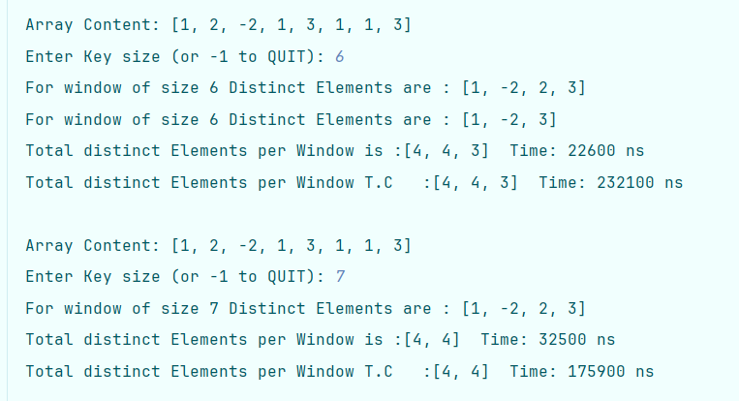
if (map.get(out) == 1) map.remove(out);
else map.put(out, map.getOrDefault(out, 0) - 1);
map.put(in, map.getOrDefault(in, 0) + 1);
list.add(map.size());
System.out.println("For window of size " + k + " Distinct Elements are : " + map.keySet());
}
return list;
}
public static List<Integer> distinctElements_PerWindow(int[] array, int k) {
/** Time Complexity = O(n * k ) */
List<Integer> list = new ArrayList<>();
HashSet<Integer> set = new HashSet<>(k);
for (int i = 0; i <= (array.length - k); i++) {
for (int j = 0; j < k; j++) {
set.add(array[i + j]);
}
list.add(set.size());
set.clear();
}
return list;
}
public static void main(String[] args) throws IOException {
int[] array = {1, 2, -2, 1, 3, 1, 1, 3};
BufferedReader bufferedReader = new BufferedReader(new
OUTPUT
InputStreamReader(System.in));
int k;
while (true) {
System.out.println("\nArray Content: " + Arrays.toString(array));
System.out.print("Enter Key size (or -1 to QUIT): ");
String input = bufferedReader.readLine();
if (input == null || input.isEmpty()) continue;
try {
k = Integer.parseInt(input);
} catch (NumberFormatException e) {
System.out.println("Invalid input. Please enter a k value : ");
continue;
}
if (k == -1) {
System.out.println("Goodbye!");
break;
}
long start = System.nanoTime();
List<Integer> result = distinctElements_PerWindow(array, k);
long end = System.nanoTime();
List<Integer> result2 = distinctElements_PerWindow_TC(array, k);
long end2 = System.nanoTime();
System.out.print("Total distinct Elements per Window is :" + result);
System.out.printf(" Time: %d ns\n", (end - start));
System.out.print("Total distinct Elements per Window T.C :" + result2);
System.out.printf(" Time: %d ns\n", (end2 - end));
}
}
}

8.2 Find All Distinct Elements in an Array ← Back to Index

Problem Statement
Faster among all 3 function HashSet > HashMap > Stream
Find total distinct elements in an array . Count Duplicate number as 1 elements like in an array int[] input = new int[]{1, 2, 3, 4, 7, 7, 7, 7, 77, 77, 77, 77, 7, 7, 7, 7, 7, 7, 7, 7, 7, 7, 7, 9}; elements 7,77 repeats many times so it is conted as 2 distinct elements only. So total disticts eloements are 7.

Code — Find All Distinct Elements in an Array
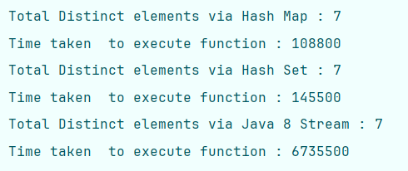
public class Find_Distinct_Elements {
// T.C O(n)
public static int findDistinctElements_HashMap(int[] array) {
HashMap<Integer, Integer> map = new HashMap<>();
for (int value : array) {
if (!map.containsKey(value)) map.put(value, 1);
}
return map.size();
}
// T.C O(n)
public static int findDistinctElements_HashSet(int[] array) {
HashSet<Integer> set = new HashSet<>();
for (int value : array) set.add(value);
return set.size();
}
// T.C O(n) but it takes much time . Modern (Java 8+)
public static long findDistinctElements_Stream(int[] array) {
return Arrays.stream(array).distinct().count();
}
static void main(String[] args) {
int[] input = new int[]{1, 2, 3, 4, 7, 7, 7, 7, 77, 77, 77, 77, 7, 7, 7, 7, 7, 7, 7, 7, 7, 7, 7, 9};
long start = System.nanoTime(); int result = findDistinctElements_HashMap(input);
long end = System.nanoTime(); int result2 = findDistinctElements_HashSet(input);
long end2 = System.nanoTime(); long result3 = findDistinctElements_Stream(input);
long end3 = System.nanoTime();
System.out.println("Total Distinct elements via Hash Map : " + result);
System.out.println("Time taken to execute function : " + (end - start));
System.out.println("Total Distinct elements via Hash Set : " + result2);
System.out.println("Time taken to execute function : " + (end2 - end));
System.out.println("Total Distinct elements via Java 8 Stream : " + result3);
System.out.println("Time taken to execute function : " + (end3 - end2));
}
}
OUTPUT

8.3 Intersection of Two Arrays ← Back to Index

Code — Intersection of Two Arrays
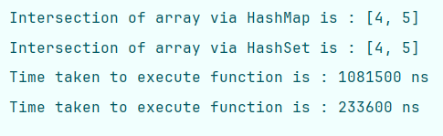
import java.util.HashMap;
import java.util.HashSet;
import java.util.Map;
public class Intersection_Of_Array {
public static int findUnion(int[] array1, int[] array2) {
HashMap<Integer, Integer> map = new HashMap<>();
for (int value : array1) map.put(value, map.getOrDefault(value, 0) + 1);
for (int value : array2) map.put(value, map.getOrDefault(value, 0) + 1);
HashSet<Integer> set = new HashSet<>();
for (Map.Entry<Integer, Integer> entry : map.entrySet()) {
if (entry.getValue() > 1) set.add(entry.getKey());
}
System.out.println("Intersection of array via HashMap is : " + set);
return set.size();
}
public static int findUnion_HashSet(int[] array1, int[] array2) {
HashSet<Integer> set = new HashSet<>();
HashSet<Integer> intersection = new HashSet<>();
for (int value : array1) set.add(value);
for (int value : array2) {
if (set.contains(value)) intersection.add(value);
}
System.out.println("Intersection of array via HashSet is : " + intersection);
return intersection.size();
}
static void main(String[] args) {
int[] array1 = {1, 2, 3, 4, 5};
int[] array2 = {11, 12, 13, 4, 5};
int result = findUnion(array1, array2);
int result2 = findUnion_HashSet(array1, array2);
}
}
OUTPUT

8.4 Subarray with Given Sum ← Back to Index

Problem Statement
To find the subArray / part of Array whose sum is equal to the target Sum. Given sub array should be sequential
Example :- for array {1,3,5,6,3,4,5} for targetSum = 14 , subarray is {5,6,3} continuously

Approach / Intuition Using HashMap
- Traverse the array while maintaining a running sum (currentSum).
- If currentSum equals the target sum, a valid subarray is found from index 0 to i.
- Store each prefix sum and its index in a HashMap.
- For each element, check if (currentSum - targetSum) exists in the HashMap.
- If it exists, the subarray from the next index of that prefix sum to the current index has the required sum.
- If no such subarray is found after traversing the array, report that the target sum does not exist.
Time Complexity: O(n)
Space Complexity: O(n)

Code — Subarray with Given Sum
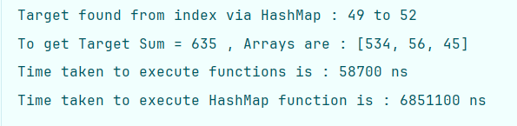
import java.util.ArrayList;
import java.util.HashMap;
import java.util.List;
public class SubArray_With_Given_Sum {
public static List<Integer> findSubArraysSum(int[] array, int targetSum) {
List<Integer> list = new ArrayList<>();
int start = 0, currentSum = 0;
for (int i = 0; i < array.length; i++) {
int value = array[i];
currentSum += value;
while (currentSum > targetSum && start < i) {
currentSum -= array[start++];
}
if (currentSum == targetSum) {
for (int j = start; j <= i; j++) {
list.add(array[j]);
}
return list;
}
}
System.out.println("Lists data are : " + list);
return list;
}
public static void findSubArraysSum_HashMap(int[] array, int targetSum) {
int currentSum = 0, start = 0, end = -1;
HashMap<Integer, Integer> map = new HashMap<>();
for (int i = 0; i < array.length; i++) {
currentSum += array[i];
if ((currentSum - targetSum) == 0) {
start = 0;
end = i;
break;
}
if (map.containsKey(currentSum - targetSum)) {
start = map.get(currentSum - targetSum);
end = i;
break;
}
map.put(currentSum, i);
}
if (end == -1)
System.out.println("Target sum not found via HashMap");
else
System.out.println("Target found from index via HashMap : " + start + " to " + end);
}
static void main(String[] args) {
int[] array = {1, 2, 3, 4, 5, 45, 3, 5, 56, 57, 6, 78, 8, 79, 89, 8, 79, 7, 86, 7, 5
, 6, 4, 5, 3, 4, 2, 456, 23, 4, 3, 5, 54, 6, 5, 7, 67, 86789, 788090, 9, -9, 0, -89, 678, 54,
OUTPUT
6, 34534, 45 , 542354, 34, 534, 56, 45, 56, 7,};
int targetSum = 635;
long startTime = System.nanoTime();
List<Integer> list = findSubArraysSum(array, targetSum);
long endTime = System.nanoTime();
findSubArraysSum_HashMap(array, targetSum);
long endTime2 = System.nanoTime();
System.out.println("To get Target Sum = " + targetSum + " , Arrays are : " + list.toString());
System.out.println("Time taken to execute functions is : " + (endTime - startTime) + " ns");
System.out.println("Time taken to execute HashMap function is : " + (endTime2 - endTime) + " ns");
}
}

Notes if Any :

8.5 Union of Two Arrays + Hashing Reports ← Back to Index

Code — Union of Two Arrays
import com.sun.source.tree.BreakTree;
import java.util.HashSet;
public class Union_Arrays {
public static HashSet<Integer> findUnion(int[] array1, int[] array2) {
HashSet<Integer> set = new HashSet<>();
for (int value1 : array1)
set.add(value1);
for (int value2 : array2)
set.add(value2);
return set;
}
static void main(String[] args) {
int[] array1 = {1, 2, 3, 4, 5};
int[] array2 = {11, 12, 13, 14, 51};
System.out.println("Union are :" + findUnion(array1, array2));
}
}
OUTPUT:
Union are :[1, 2, 3, 51, 4, 5, 11, 12, 13, 14]

Notes if Any :

For Detailed Notes on Hashing ( HashMap & HashSet ) , please visit https://github.com/manishrnl/DSA-Practice-Problem/blob/main/08%20Hashing/Hashing-report.md

8.6 Hashing — Extra Notes ← Back to Index

Module 09: Heap (Priority Queue)

9.1 Min Heap Implementation ← Back to Index

Problem Statement
Implement Insertion and Deletion operations in a Min Heap using an array representation.
A Min Heap is a complete binary tree where the value of every parent node is smaller than or equal to its child nodes.
In Min Heap, Parent node must always be smaller than child nodes . Array representation formulas:
- Parent = (i - 1) / 2
- Left Child = 2 * i + 1
- Right Child = 2 * i + 2
The program should:
- Insert a new element into the Min Heap while maintaining the heap property.
- Delete a given element from the Min Heap and restore the heap structure after deletion.

Approach / Intuition
1. Insertion in Min Heap : Idea
When inserting a new element:
- Add the element at the last position of the heap.
- Compare it with its parent.
- If the inserted element is smaller than its parent, swap them.
- Continue moving upward until the Min Heap property is satisfied.
This process is called Heapify Up (or Bubble Up).
Steps
- Create a new array with one extra space.
- Copy existing heap elements.
- Insert the new value at the last index.
- Find its parent using (childIndex - 1) / 2.
- While the child is smaller than the parent:
  - Swap child and parent.
  - Move to the parent's index.
- Stop when the heap property is restored.
2. Deletion from Min Heap : Idea -To delete an element:
- Find the element's index.
- Replace it with the last element of the heap.
- Remove the last element.
- Restore the heap property by moving the replaced node downward.
This process is called Heapify Down (or Bubble Down).
Steps
- Search for the value to delete.
- Store its index.
- Replace it with the last heap element.
- Reduce heap size by one.
- Compare the replaced node with its children.
- Swap with the smaller child if required.
- Continue until the Min Heap property is restored.

Code — Min Heap Implementation
public class MinHeap {
public static void insertInto_MinHeap(int[] array, int value) {
int[] newArray = new int[array.length + 1]; // Create new array with one extra space
System.arraycopy(array, 0, newArray, 0, array.length); // Copy original heap
newArray[array.length] = value; // Insert new value at LAST position
System.out.println("Before Heapify:" + Arrays.toString(newArray));
int childIndex = newArray.length - 1; // Child index = last index
while (childIndex > 0) {
int parentIndex = (childIndex - 1) / 2; // Find parent
if (newArray[childIndex] < newArray[parentIndex]) { // Min Heap condition
int temp = newArray[childIndex];
newArray[childIndex] = newArray[parentIndex];
newArray[parentIndex] = temp;
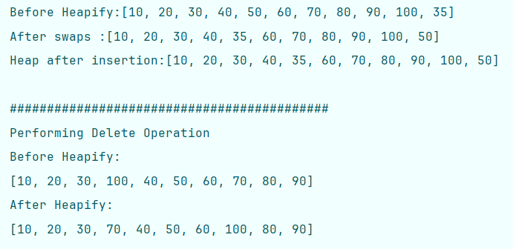
childIndex = parentIndex; // Move upward
System.out.println("After swaps :" + Arrays.toString(newArray));
} else break;
}
System.out.println("Heap after insertion:" + Arrays.toString(newArray));
}
public static void deleteFrom_MinHeap(int[] array, int value) {
System.out.println("\n###########################################");
System.out.println("Performing Delete Operation");
int length = array.length;
int deletedIndex = -1;
// Step 1: Find element
for (int i = 0; i < length; i++) {
if (array[i] == value) {
deletedIndex = i;
break;
}
}
// Value not found
if (deletedIndex == -1) {
System.out.println("Value not found.");
return;
}
OUTPUT
// Step 2: Replace deleted node with last node
array[deletedIndex] = array[length - 1];
// Step 3: Remove last element
int[] newArray = Arrays.copyOf(array, length - 1);
System.out.println("Before Heapify:");
System.out.println(Arrays.toString(newArray));
int current = deletedIndex;
// Step 4: Heapify Down
while (true) {
int leftChild = 2 * current + 1;
int rightChild = 2 * current + 2;
int smallest = current;
// Compare left child
if (leftChild < newArray.length && newArray[leftChild] < newArray[smallest]) smallest = leftChild;
// Compare right child
if (rightChild < newArray.length && newArray[rightChild] < newArray[smallest]) smallest = rightChild;
// Heap property satisfied
if (smallest == current) break;
// Swap
int temp = newArray[current];
newArray[current] = newArray[smallest];
newArray[smallest] = temp;
// Move downward
current = smallest;
}
System.out.println("After Heapify ”+ Arrays.toString(newArray));
}
public static void main(String[] args) {
int[] array = {10, 20, 30, 40, 50, 60, 70, 80, 90, 100};
int value = 35;
insertInto_MinHeap(array, value);
deleteFrom_MinHeap(new int[]{10, 20, 30, 35, 40, 50, 60, 70, 80, 90, 100}, value);
}
}
Operation | Technique Used | Time Complexity | Space Complexity
Insert | Heapify Up | O(log n) | O(n)
Delete | Search + Heapify Down | O(n) | O(n)

Notes if Any :

9.2 Max Heap Implementation + Heap Reports ← Back to Index

Problem Statement
Implement Insertion and Deletion operations in a Max Heap using an array representation.
A Max Heap is a complete binary tree where the value of every parent node is greater than or equal to its child nodes.
Array representation formulas (0-based indexing):
- Parent = (i - 1) / 2
- Left Child = 2 * i + 1
- Right Child = 2 * i + 2
The program should:
- Insert a new element into the Max Heap while maintaining the heap property.
- Delete a given element from the Max Heap and restore the heap structure after deletion.

Approach / Intuition
1. Insertion in Max Heap . Idea : When inserting a new element:
- Place the new element at the last position of the heap.
- Compare it with its parent.
- If the inserted element is greater than its parent, swap them.
- Continue moving upward until the Max Heap property is satisfied.
This process is called Heapify Up (or Bubble Up).
Steps
- Create a new array with one extra space.
- Copy all existing heap elements into the new array.
- Insert the new value at the last index.
- Find its parent using (childIndex - 1) / 2.
- While the child is greater than the parent:
  - Swap parent and child.
  - Move to the parent's position.
- Stop when the heap property is restored.
2. Deletion from Max Heap. Idea: To delete an element:
- Find the index of the element to be deleted.
- Replace it with the last element of the heap.
- Remove the last element.
- Restore the heap property by moving the replaced node downward.
This process is called Heapify Down (or Bubble Down).
Steps
- Search for the value to delete.
- Store its index.
- Replace it with the last heap element.
- Reduce heap size by one.
- Compare the replaced node with its children.
- Swap with the larger child if necessary.
- Continue until the Max Heap property is restored.

Code — Max Heap Implementation
public class MaxHeap {
public static void insertInto_MaxHeap(int[] array, int value) {
int[] newArray = new int[array.length + 1]; // Step 1: Create new array with extra space
System.arraycopy(array, 0, newArray, 0, array.length);
newArray[array.length] = value; // Step 2: Insert new value at last position
int childIndex = newArray.length - 1; // Child index = last index
System.out.println("Original Arrays are : " + Arrays.toString(newArray));
while (childIndex > 0) { // Step 3: Heapify Up
int parentIndex = (childIndex - 1) / 2; // Find parent index
if (newArray[childIndex] > newArray[parentIndex]) {// If child > parent → swap
int temp = newArray[childIndex];
newArray[childIndex] = newArray[parentIndex];
newArray[parentIndex] = temp;
childIndex = parentIndex; // Move upward
} else {
// Heap property satisfied
break;
}
System.out.println("After Swaps : " + Arrays.toString(newArray));
}
System.out.println("Heap after insertion:" + Arrays.toString(newArray));
}
public static void deleteFrom_MaxHeap(int[] array, int value) {
System.out.println("\n#############################\nPerforming Delete operations for value : " + value);
int n = array.length;
int deleteIndex = -1; // Step 1: Find index of value which needs to be deleted
for (int i = 0; i < n; i++) {
if (array[i] == value) {
deleteIndex = i;
break;
}
}
if (deleteIndex == -1) { // Value not found
System.out.println("Value not found in heap , retry with valid data ...");
return;
}
array[deleteIndex] = array[n - 1]; // Step 2: Replace delete element with last element
int[] newHeap = Arrays.copyOf(array, n - 1); // Step 3: Create new array excluding last element
System.out.println("Before Heapify:" + Arrays.toString(newHeap));
int currentIndex = deleteIndex;
while (true) { // Step 4: Heapify Down
int leftChild = (2 * currentIndex + 1), rightChild = (2 * currentIndex + 2), largest = currentIndex;
if (leftChild < newHeap.length && newHeap[leftChild] > newHeap[largest]) // Compare left child
largest = leftChild;
if (rightChild < newHeap.length && newHeap[rightChild] > newHeap[largest]) // Compare right child
largest = rightChild;
if (largest == currentIndex) // Heap property satisfied
break;
int temp = newHeap[currentIndex];
newHeap[currentIndex] = newHeap[largest];
newHeap[largest] = temp;
currentIndex = largest; // Move downward
}
System.out.println("Heap after deletion:" + Arrays.toString(newHeap));
}
public static void main(String[] args) {
int[] array = {90, 70, 60, 40, 50, 20, 10};
int value = 80;
insertInto_MaxHeap(array, value);
deleteFrom_MaxHeap(new int[]{90, 80, 70, 60, 40, 50, 20, 10}, value);
}
}

Operation | Technique Used | Time Complexity | Space Complexity
Insert | Heapify Up | O(log n) | O(n)
Delete | Search + Heapify Down | O(n) | O(n)

Notes if Any :

For Detailed Notes on Heap , please visit https://github.com/manishrnl/DSA-Practice-Problem/blob/main/09%20Heap%20Data%20Structures/README.md

9.3 Heap (Priority Queue) — Extra Notes ← Back to Index

Module 10 :

10.1 Sub-Module Name ← Back to Index

Problem Statement
while (childIndex > 0) { // Step 3: Heapify Up

Approach / Intuition
while (childIndex > 0) { // Step 3: Heapify Up

Code — Heap Theory (complete binary tree, heap order property)
public class Solution {

}

Notes if Any :

